

**DEPARTMENT OF INFORMATION TECHNOLOGY**

**LAB MANUAL**

**CS23432 – Software Construction**

**(REGULATION 2023)**

**RAJALAKSHMI ENGINEERING COLLEGE**

**Thandalam, Chennai-602015**

Name: DHARSHINI.H

Register No: 231001035

Year / Branch / Section: 2nd /IT/ FA

Semester: IV

Academic Year: 2024 - 2025

INDEX

| S.No. | Date | Title |
| --- | --- | --- |
| 1. | 22/01/25 | Azure Devops Environment Setup. |
| 2. | 07/02/25 | Azure Devops Project Setup and User Story Management. |
| 3. | 14/02/25 | Setting Up Epics, Features, And User Stories for Project Planning. |
| 4. | 20/03/25 | Sprint Planning. |
| 5. | 28/03/25 | Poker Estimation. |
| 6. | 04/04/25 | Designing Class and Sequence Diagrams for Project Architecture. |
| 7. | 16/04/25 | Designing Architectural and ER Diagrams for Project Structure. |
| 8. | 18/04/25 | Testing – Test Plans and Test Cases. |
| 9. | 25/04/25 | Load Testing and Pipelines. |
| 10. | 02/05/25 | GitHub: Project Structure & Naming Conventions. |

| **EX NO: 1**  **Date:22/01/2025** | **AZURE DEVOPS ENVIRONMENT SETUP** |
| --- | --- |

**Aim:** To set up and access the Azure DevOps environment by creating an organization through the Azure portal.

**INSTALLATION**

1.Open your web browser and go to the Azure website: https://azure.microsoft.com/en-us/get started/azure-portal.

Sign in using your Microsoft account credentials.

If you don't have a Microsoft account, you can create one here: https://signup.live.com/?lic=1 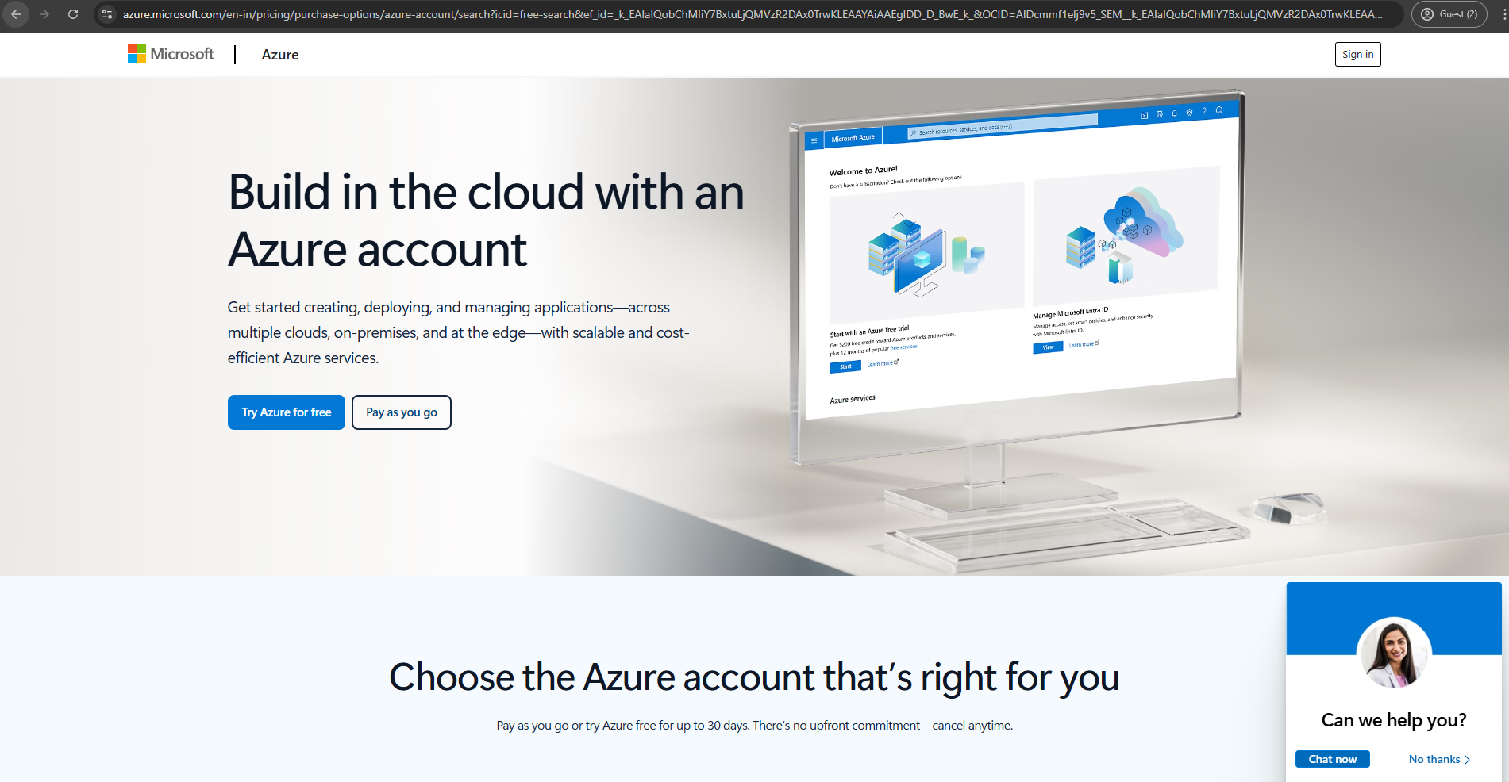

2.Azure home page

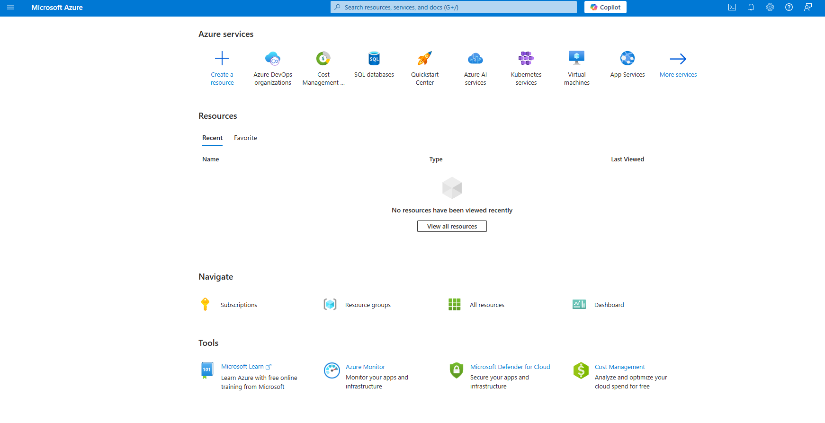

3.Open the DevOps environment in the Azure platform by typing ***Azure DevOps Organizations*** in the search bar.

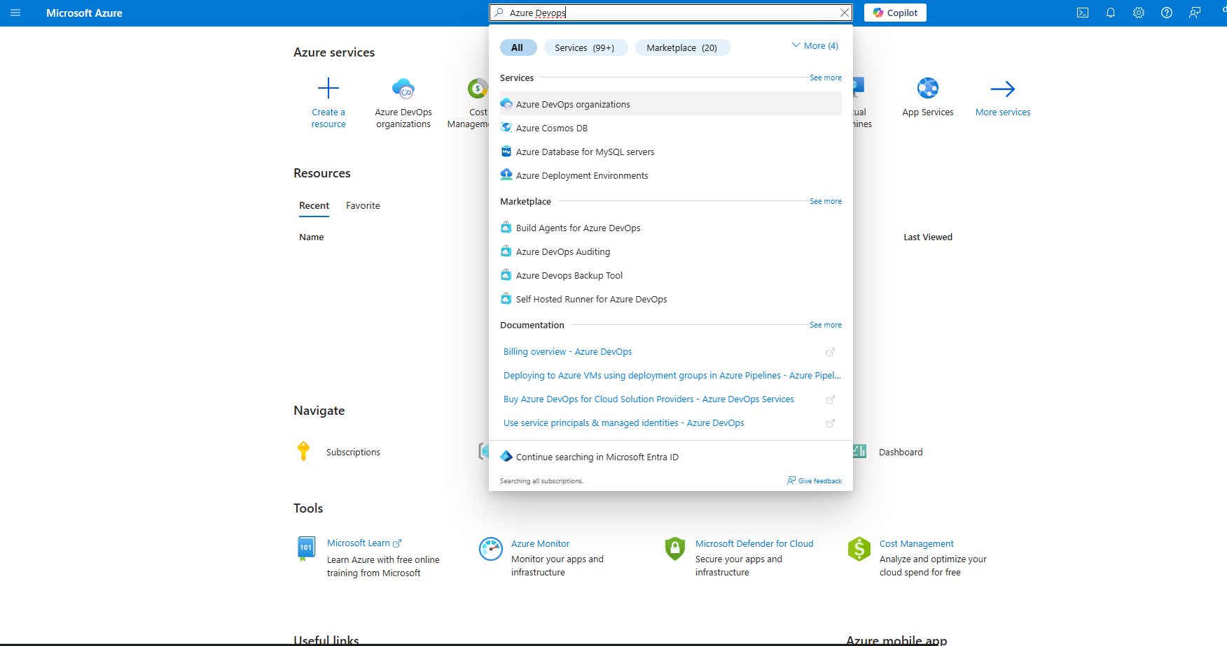

4.Click on the ***My Azure DevOps Organization*** link and create an organization and you should be taken to the Azure DevOps Organization Home page.

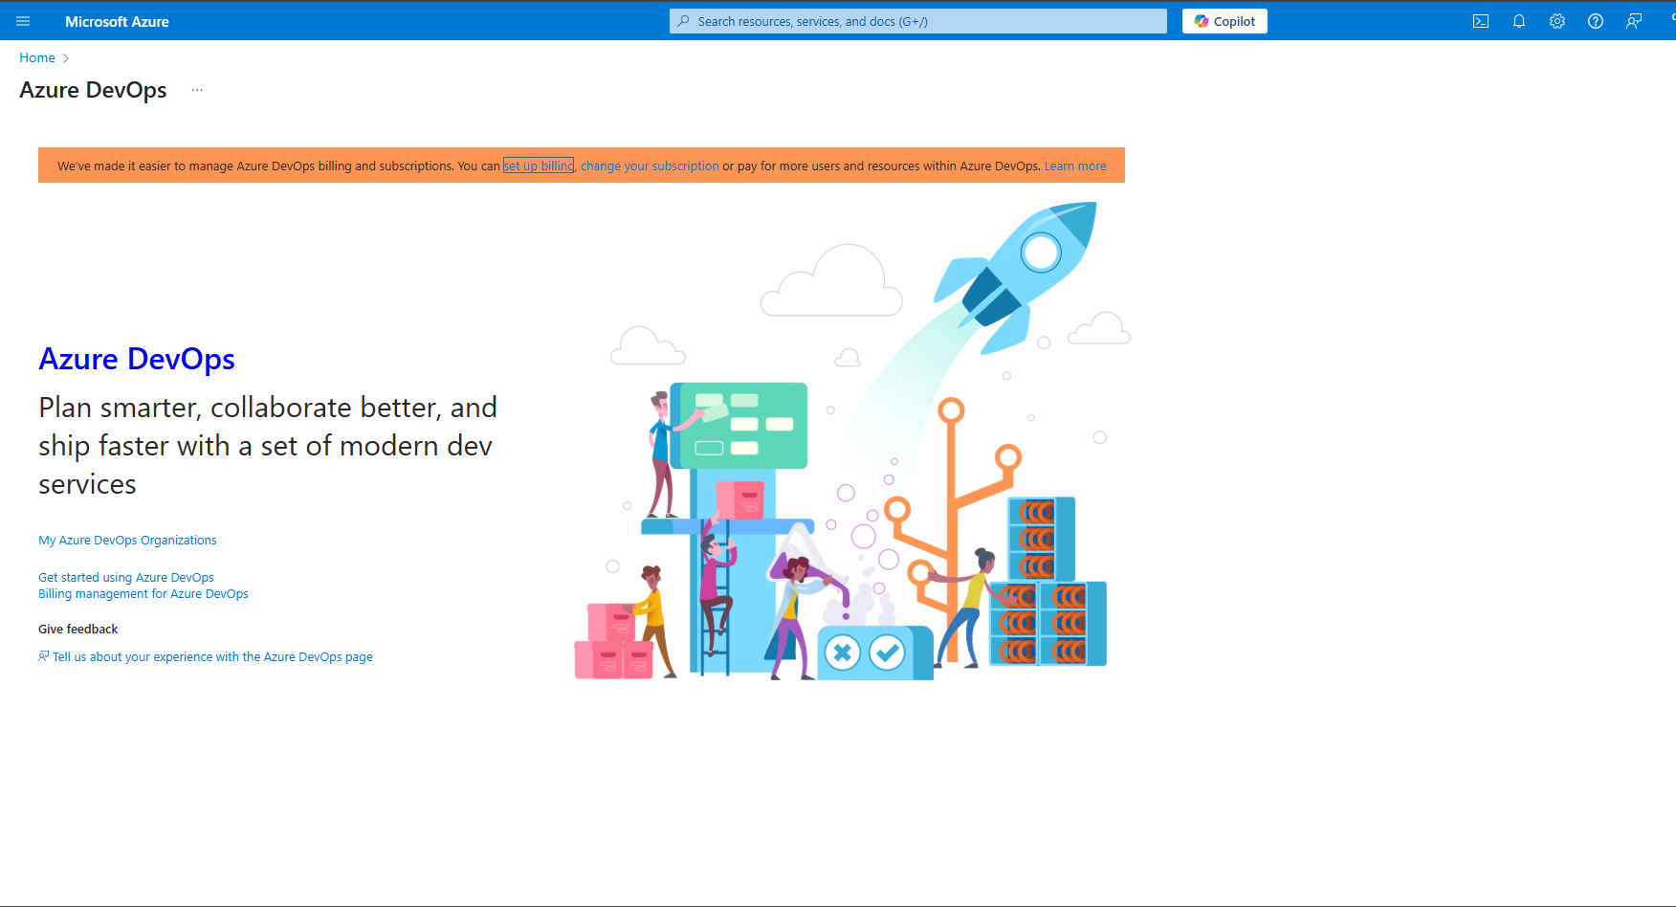

**Result:**

Successfully accessed the Azure DevOps environment and created a new organization through the Azure portal.

| **EX NO:2**  **Date: 07/02/2025** | **AZURE DEVOPS PROJECT SETUP AND USER STORY MANAGEMENT** |
| --- | --- |

**Aim:** To set up an Azure DevOps project for efficient collaboration and agile work management.

1.Create An Azure Account

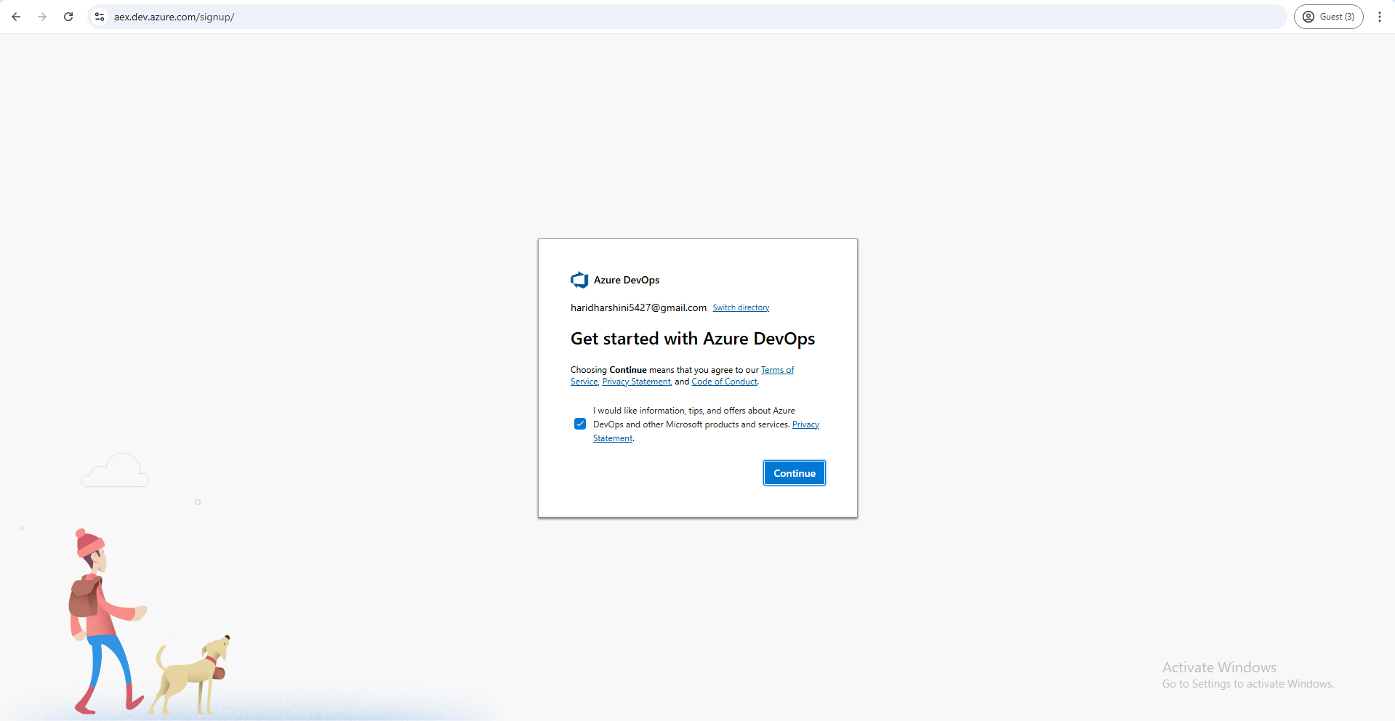

2.Create the First Project in Your Organization

a. After the organization is set up, you’ll need to create your first **project**. This is where you'll begin to manage code, pipelines, work items, and more.

b. On the organization’s **Home page**, click on the **New Project** button.

c. Enter the project name, description, and visibility options:

***Name****:* Choose a name for the project (e.g., LMS).

***Description****:* Optionally, add a description to provide more context about the project.

***Visibility****:* Choose whether you want the project to be **Private** (accessible only to

those invited) or **Public** (accessible to anyone).

d. Once you’ve filled out the details, click **Create** to set up your first project.

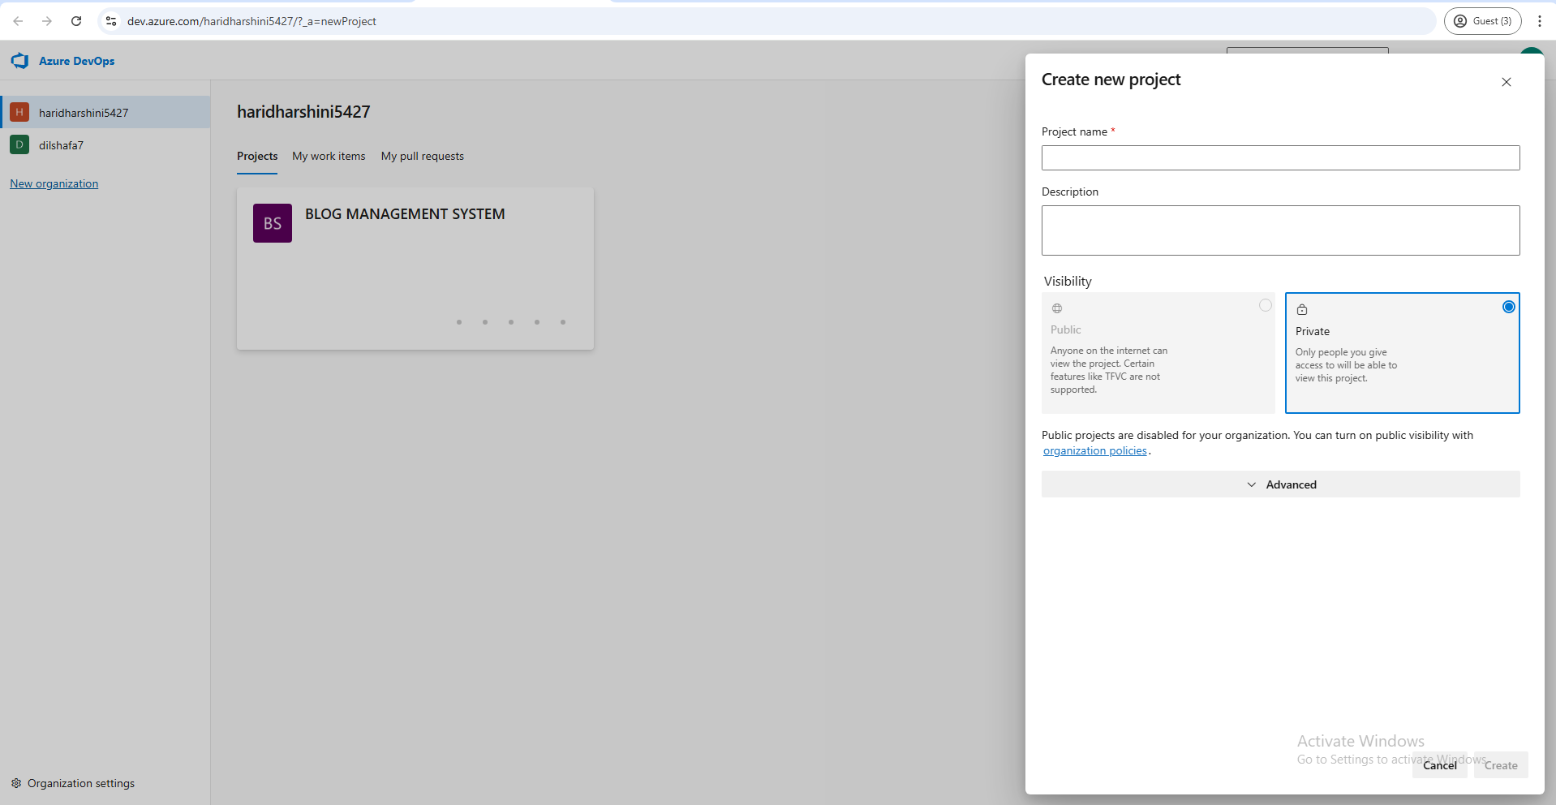

3.Once logged in, ensure you are in the correct organization. If you're part of multiple organizations, you can switch between them from the top left corner (next to your user profile). Click on the Organization name, and you should be taken to the Azure DevOps Organization Home page.

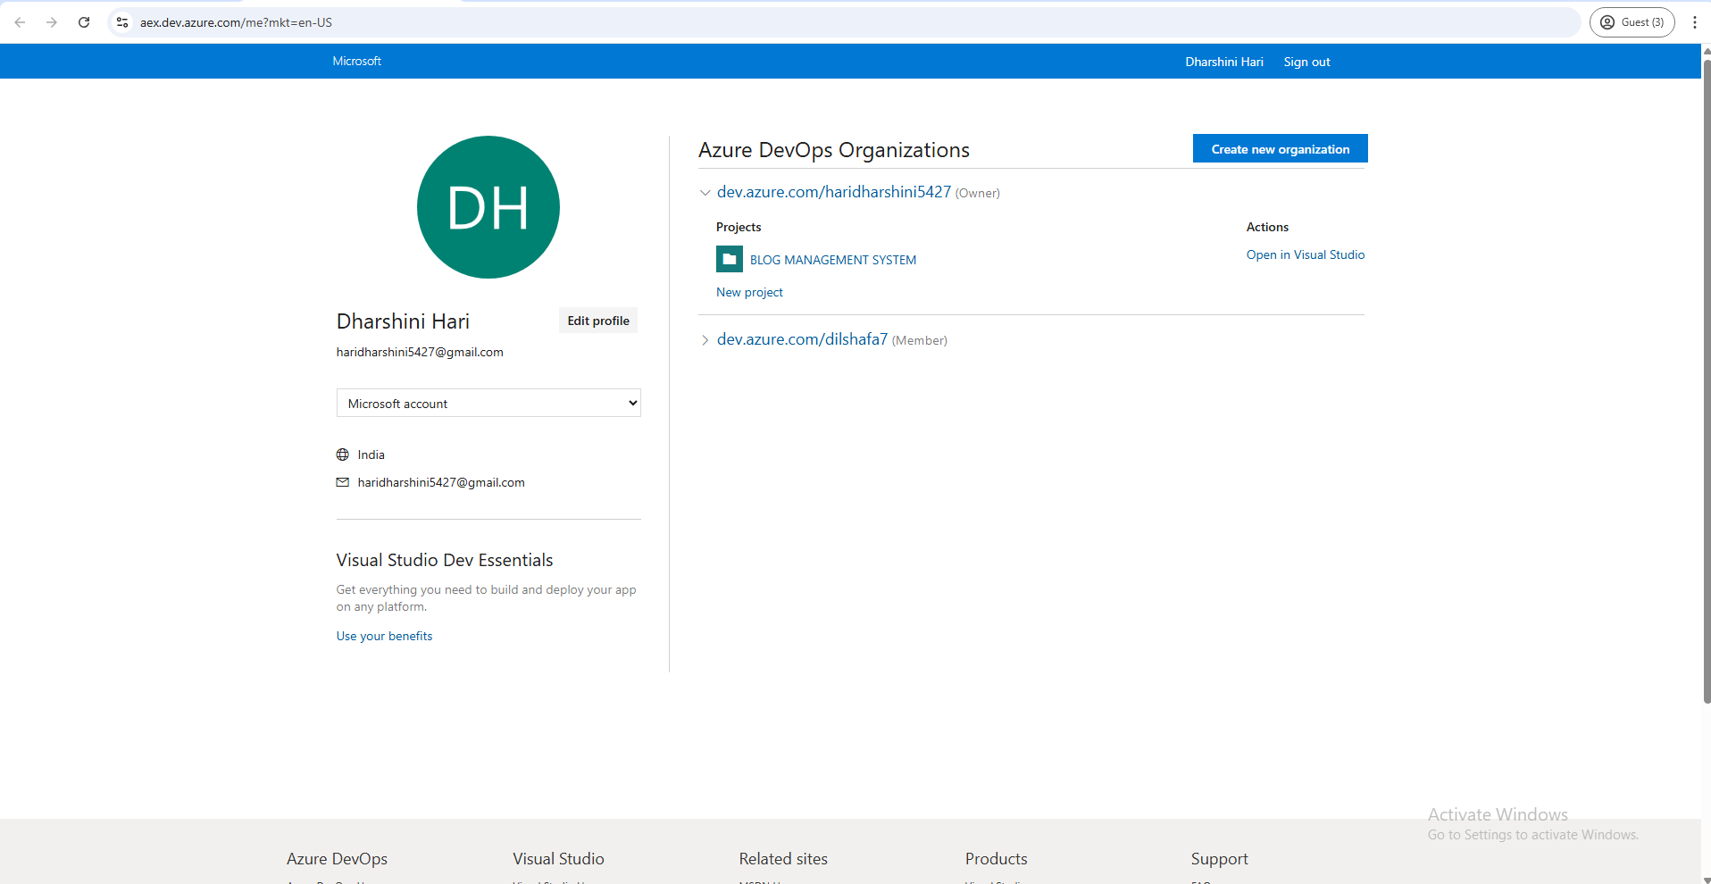

4.Project dashboard

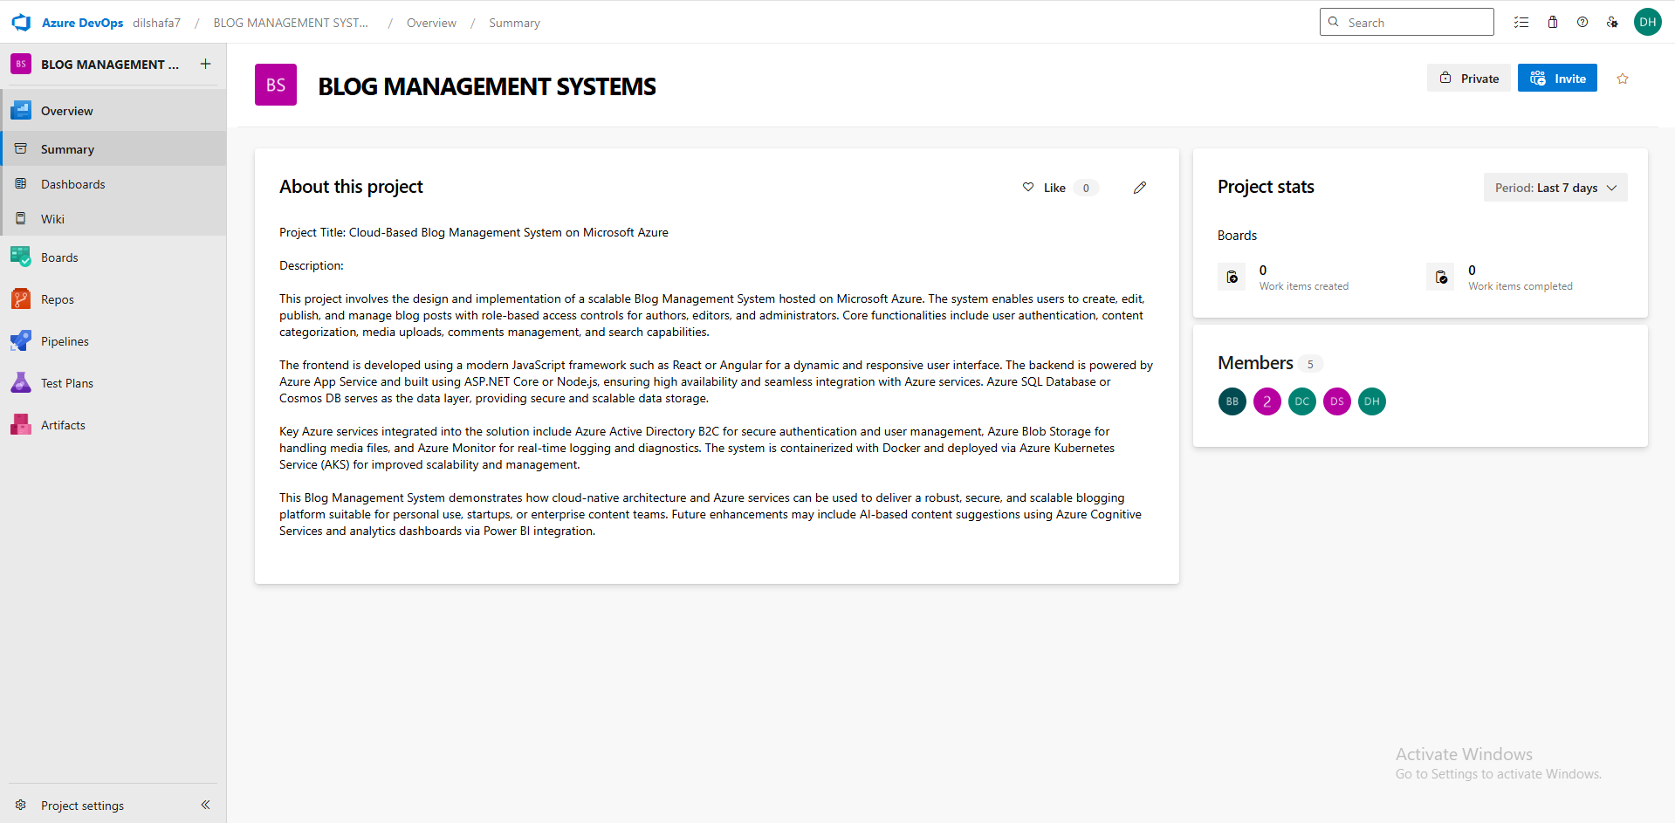

5.To manage user stories:

a. From the **left-hand navigation menu**, click on **Boards**. This will take you to the

main **boards** page, where you can manage work items, backlogs, and sprints.

b. On the **work items** page, you'll see the option to **Add a work item** at the top.

Alternatively, you can find a **+** button or **Add New Work Item** depending on the

view you're in. From the **Add a work item** dropdown, select **User Story**. This will

open a form to enter details for the new User Story.

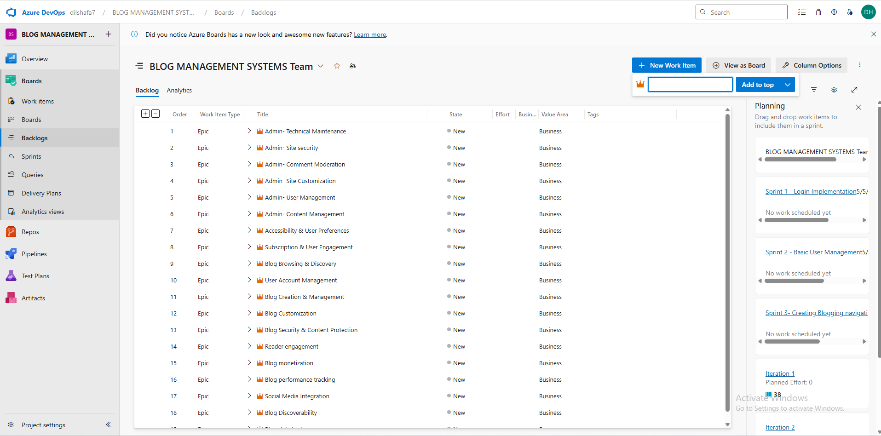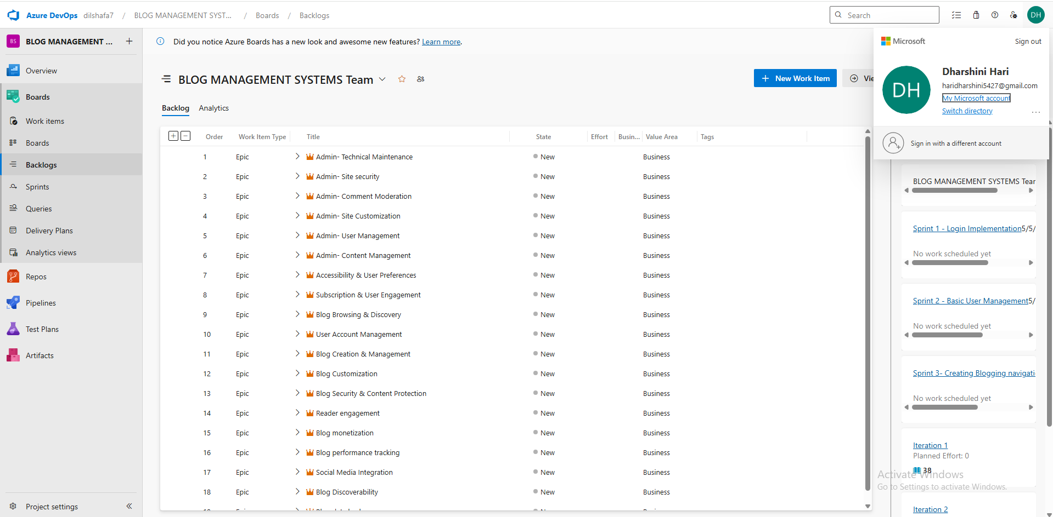

**Result:**

Successfully created an Azure DevOps project with user story management and agile workflow setup.

| **EX NO: 3**  **Date: 14/02/2025** | **SETTING UP EPICS, FEATURES, AND USER STORIES FOR PROJECT PLANNING** |
| --- | --- |

**Aim:** To learn about how to create epics, user story, features, backlogs for your assigned project.

**Create Epic, Features, User Stories, Task**

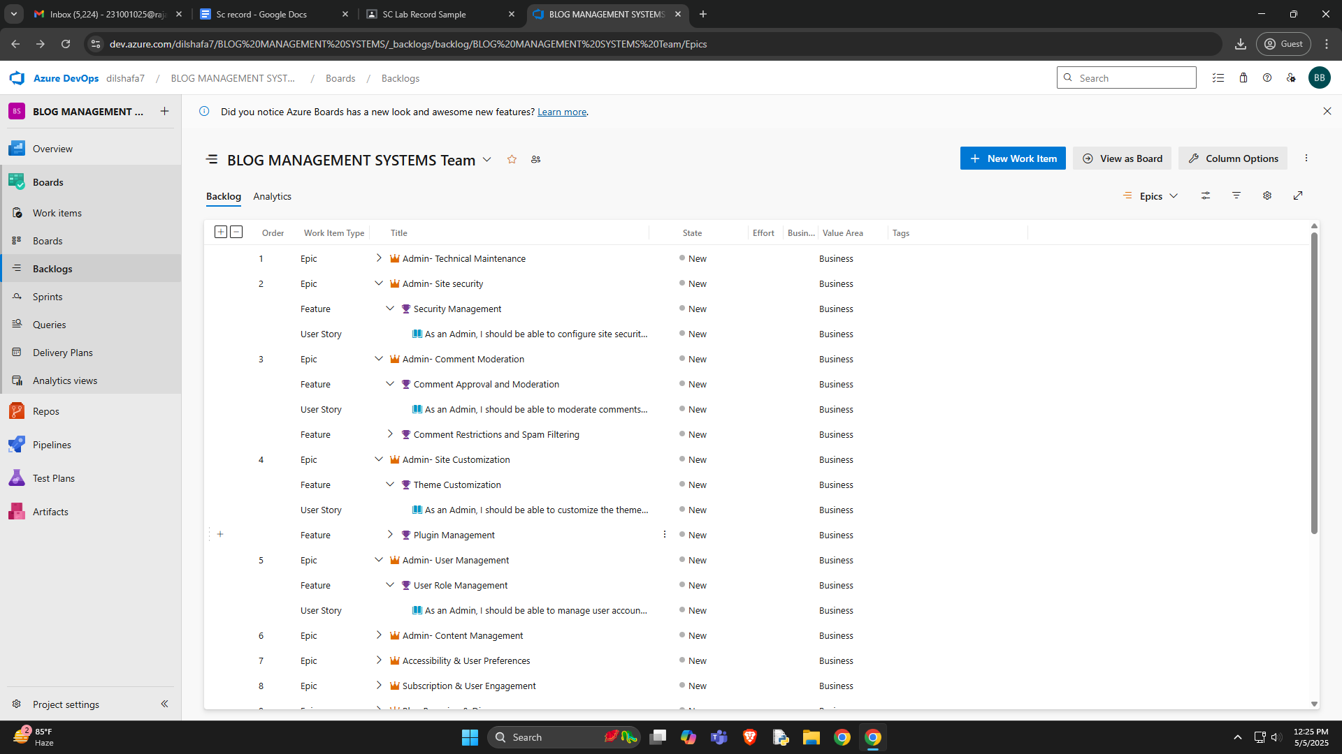

**1.Fill in Epics**

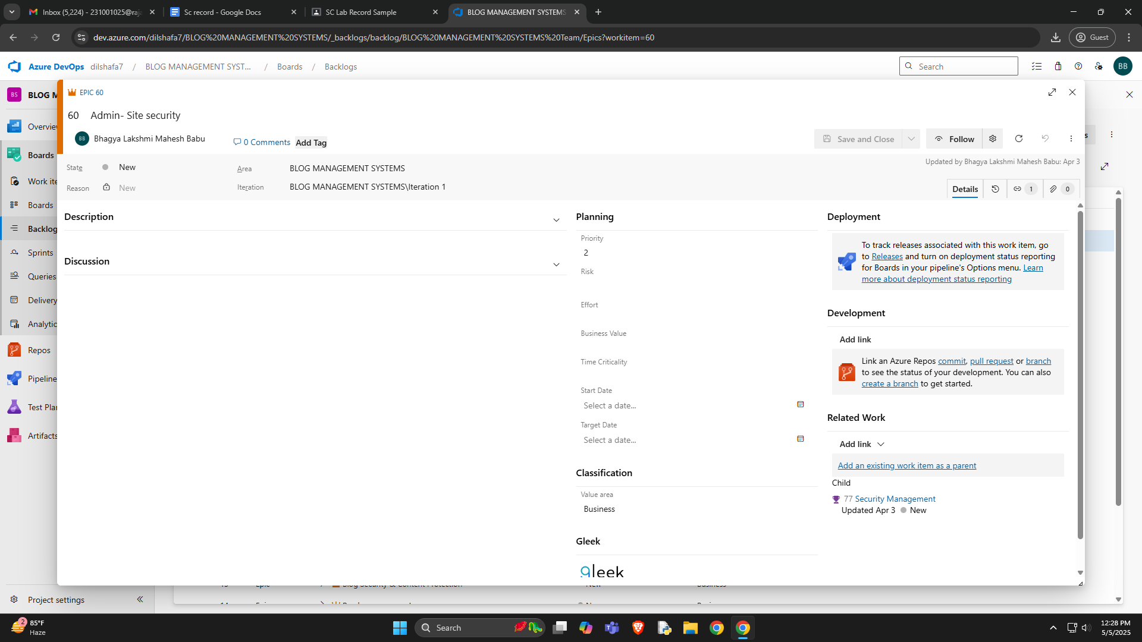

**2.Fill in Features**

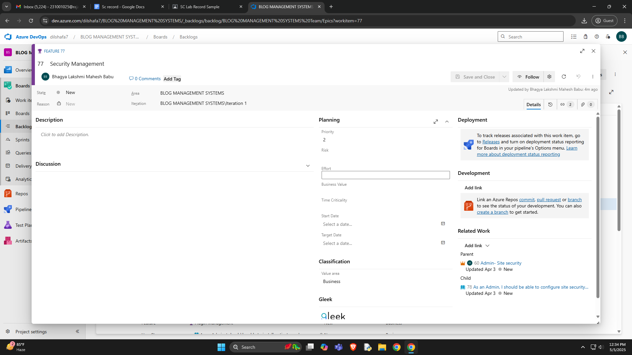

**3.Fill in User Story Details**

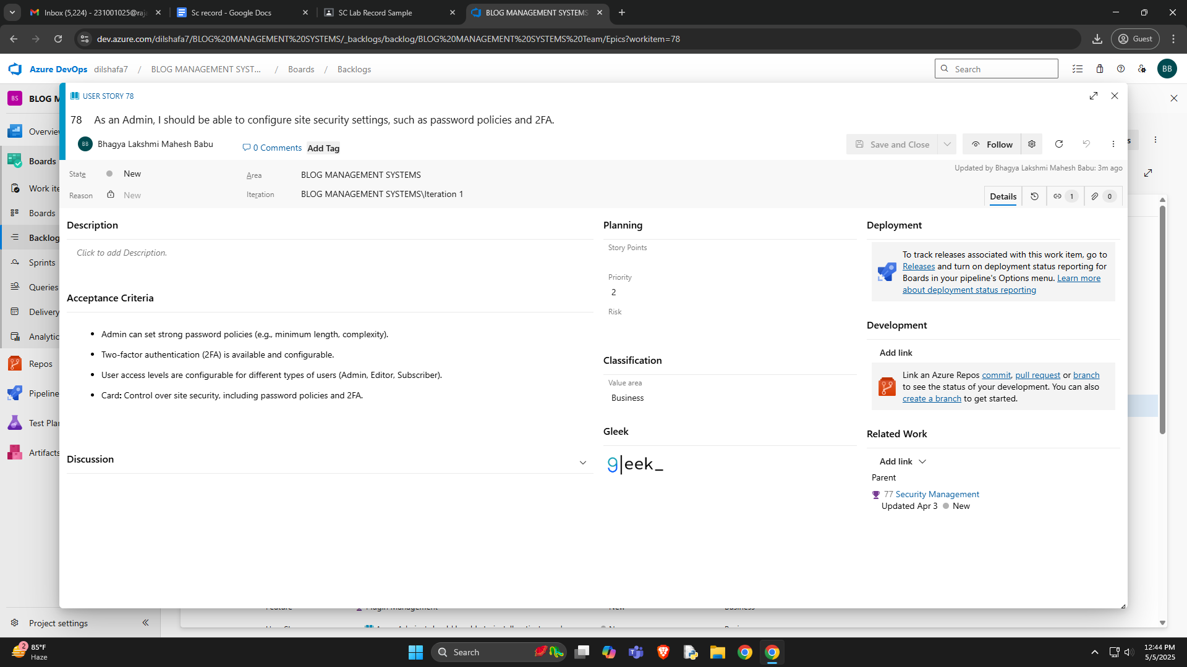

**Result:**

Thus, the creation of epics, features, user story and task has been created successfully.

| **EX NO: 4**  **Date: 20/03/2025** | **SPRINT PLANNING** |
| --- | --- |

**Aim:** To assign user story to a specific sprint for the Blog Management System Project.

**Sprint Planning**

**Sprint 1**

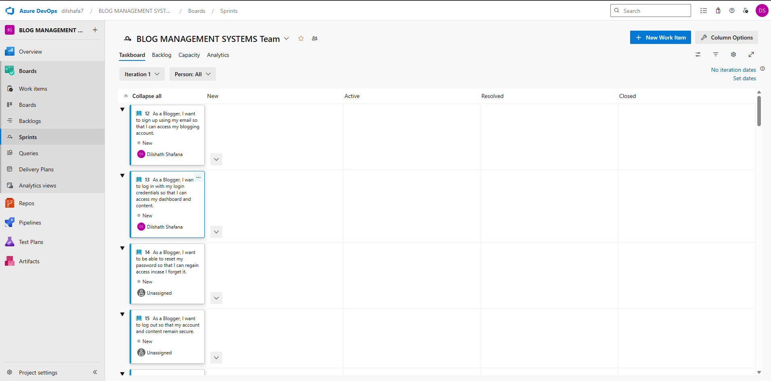

**Sprint 2** 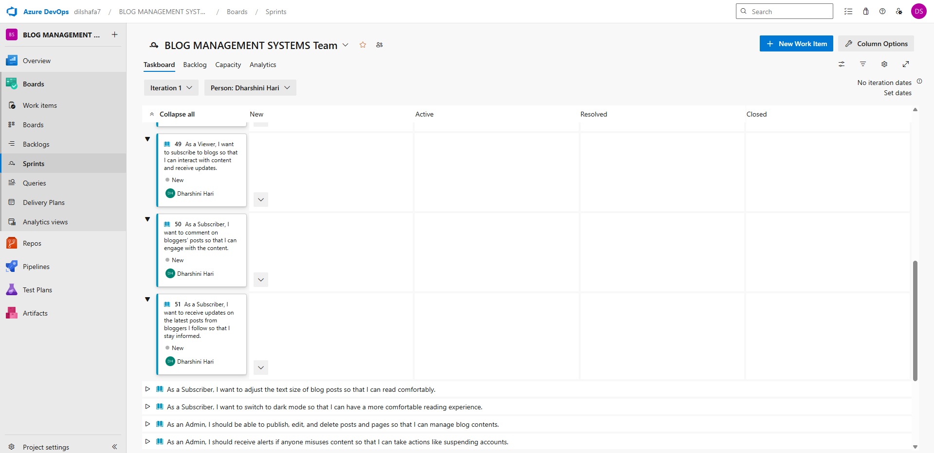

**Sprint 3**

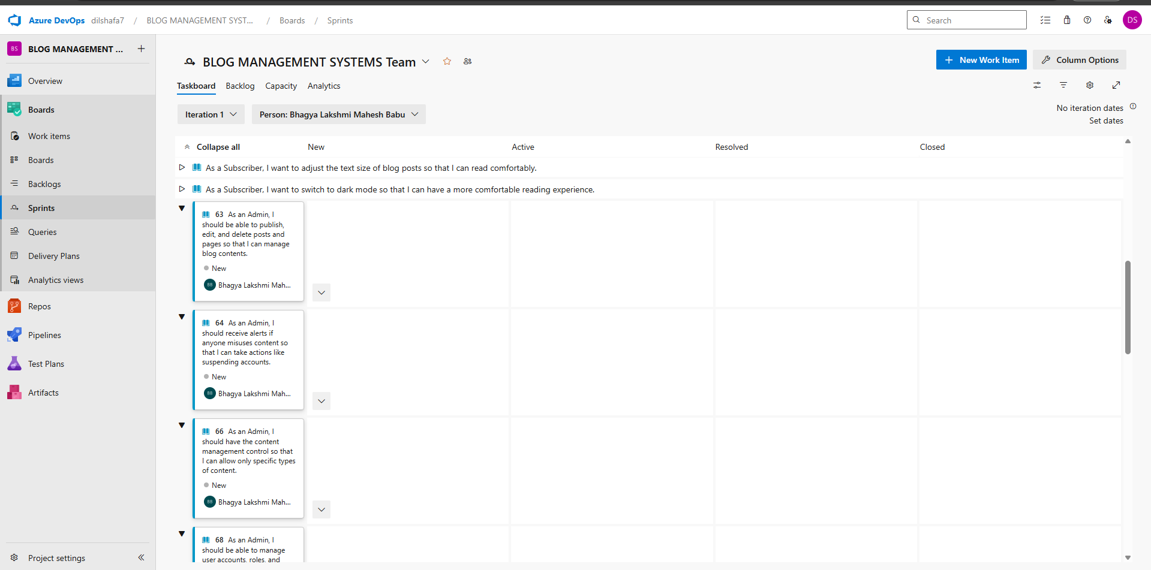

**Sprint 4**

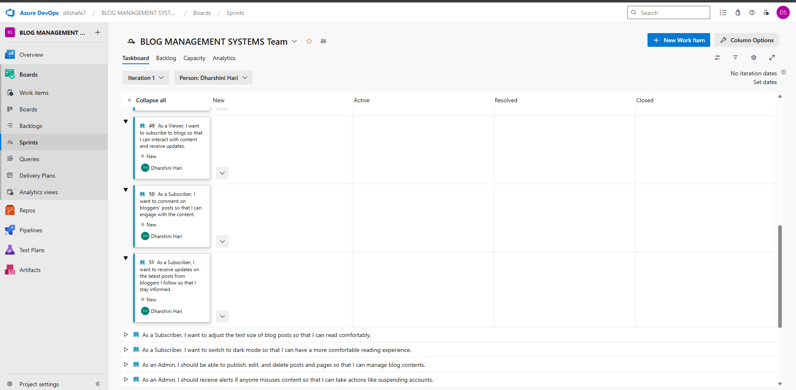

**Result:**

The Sprints are created for the Blog Management System.

| **EX NO: 5**  **Date: 28/03/2025** | **POKER ESTIMATION** |
| --- | --- |

**Aim:** Create Poker Estimation for the user stories - Blog Management System.

**Poker Estimation**

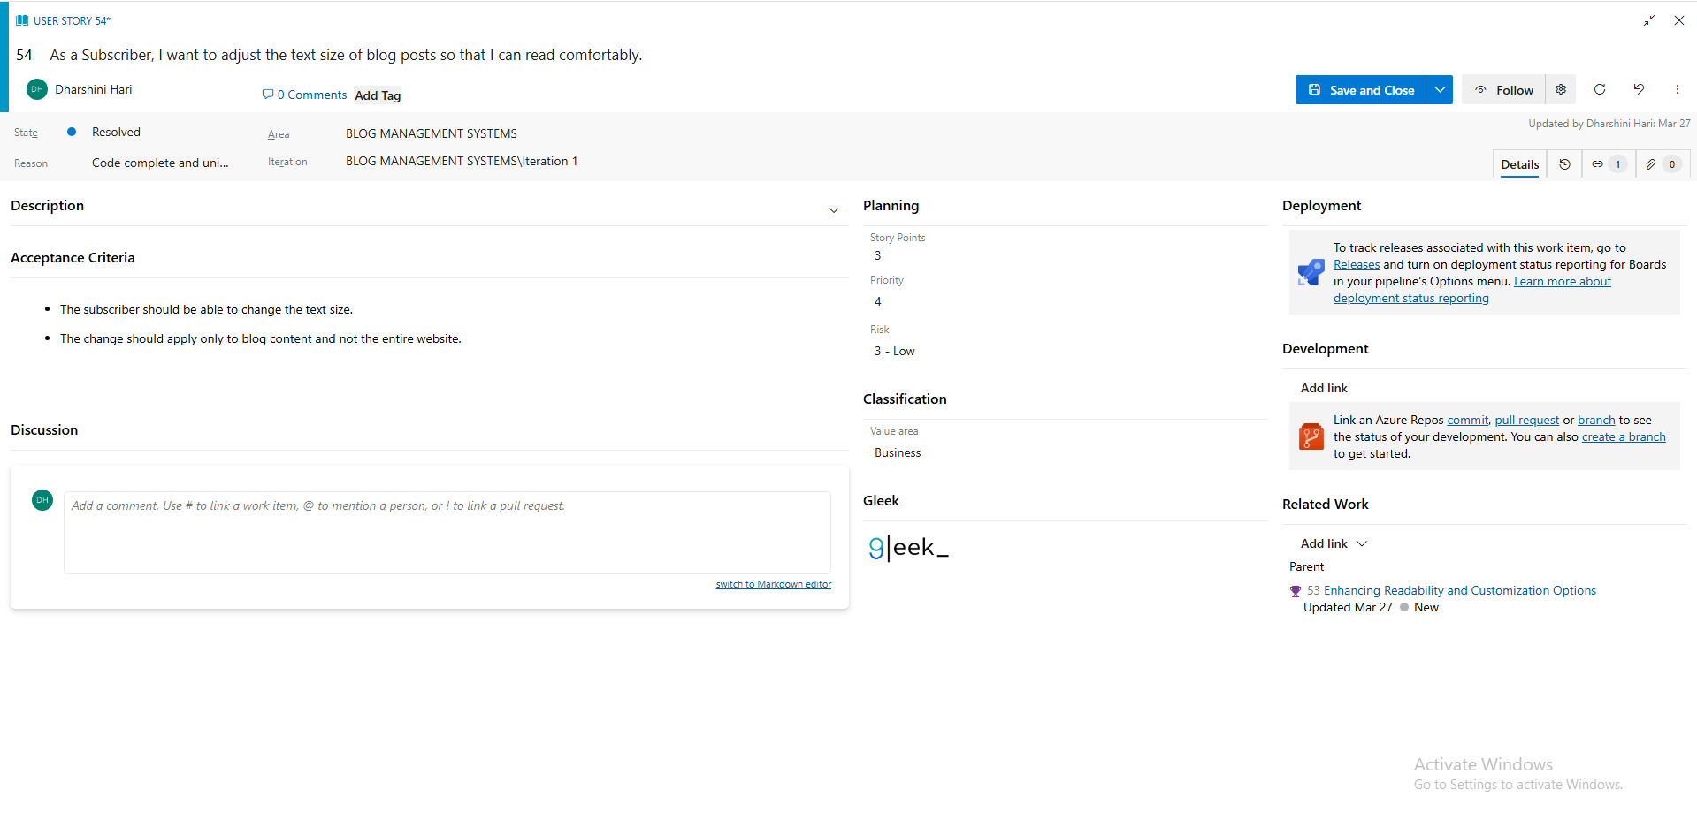

**Result:**

The Estimation/Story Points is created for the project using Poker Estimation.

| **EX NO: 6**  **Date:04/04/2025** | **DESIGNING CLASS AND SEQUENCE DIAGRAMS FOR PROJECT ARCHITECTURE** |
| --- | --- |

**Aim:** To Design a Class Diagram and Sequence Diagram for the given Project.

**6A. Class Diagram**

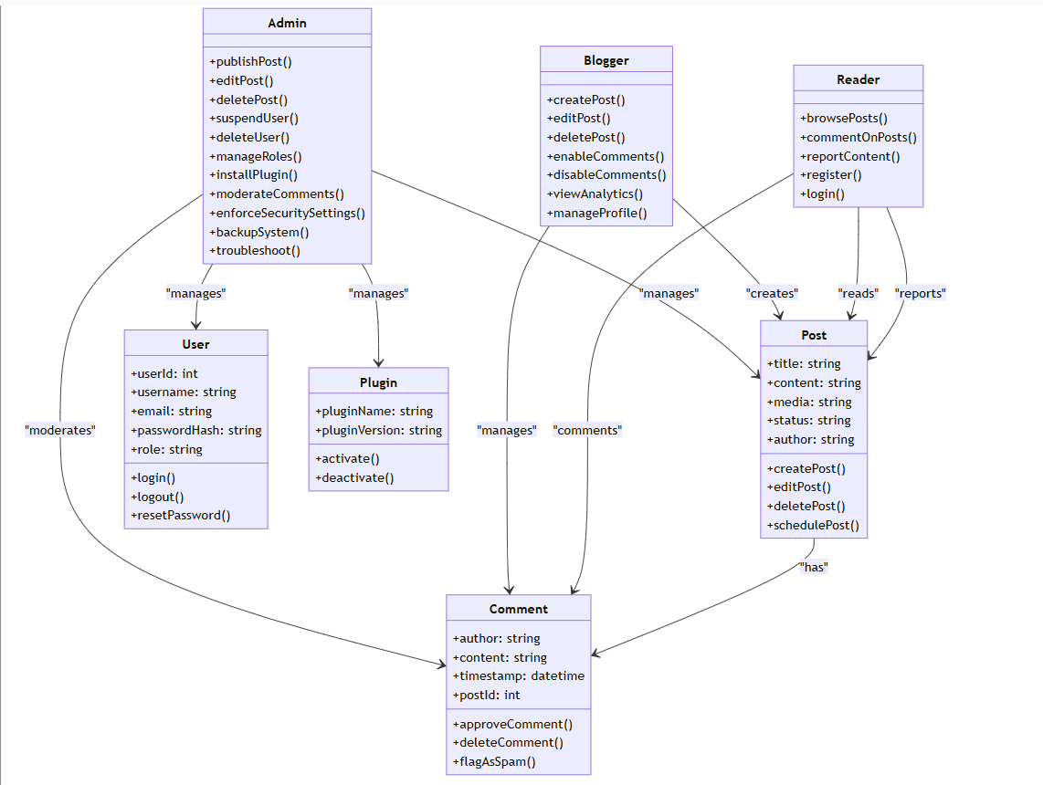

**6B. Sequence Diagram**

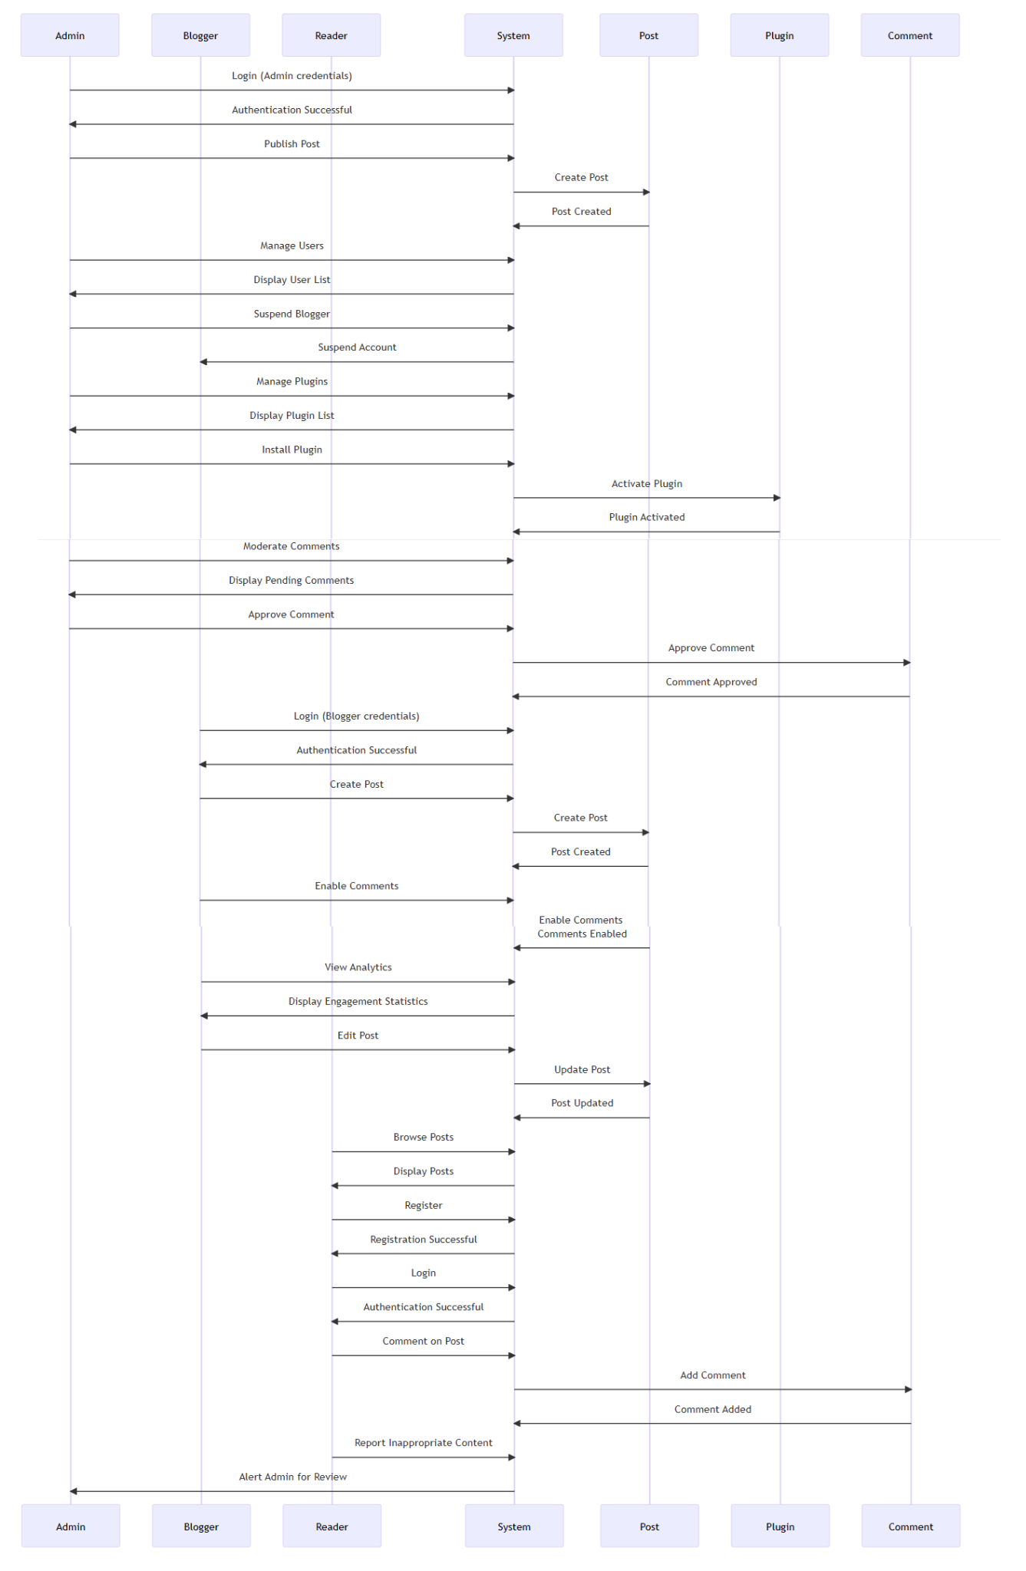

**Result:**

The class diagram and sequence diagram is designed successfully for the Blog Management system.

| **EX NO: 7**  **Date:16/04/2025** | **DESIGNING ARCHITECTURAL AND ER DIAGRAMS FOR PROJECT STRUCTURE** |
| --- | --- |

**Aim:** To Design an Architectural Diagram and ER Diagram for Blog management system.

**7A. Architectural Diagram**

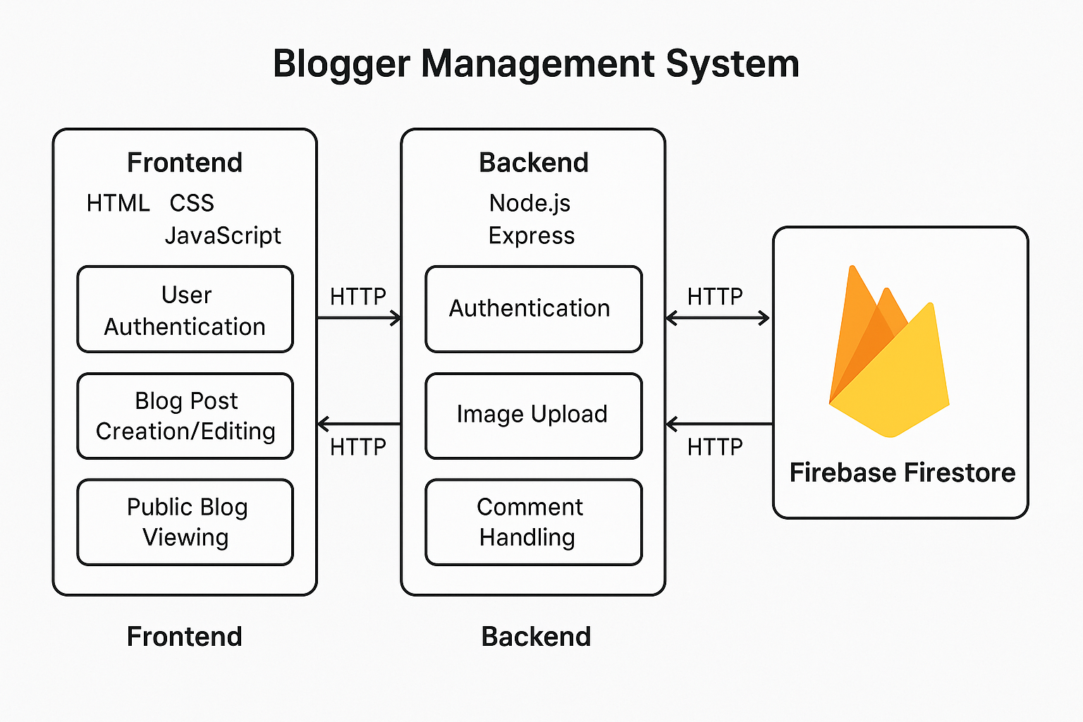

**7B.ER Diagram**

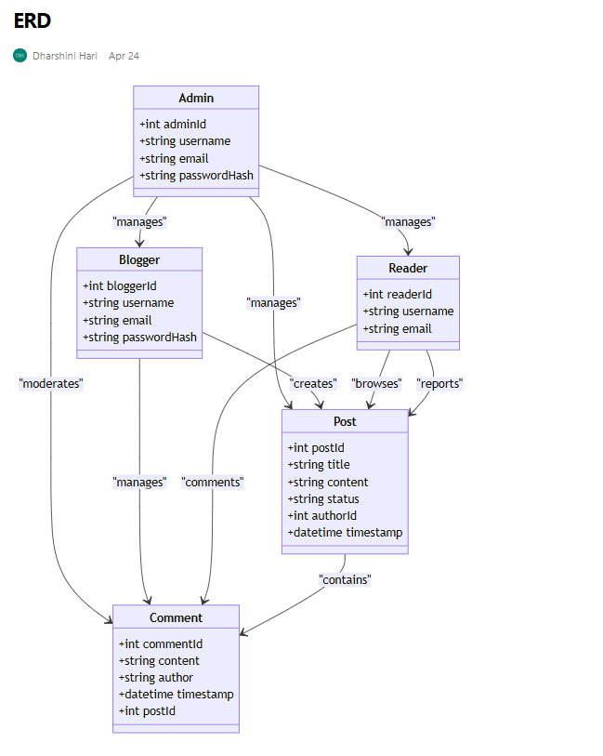

**Result:**

The Architecture Diagram and ER Diagram is designed Successfully for the Blog management system.

| **EX NO: 8**  **Date:18/04/2025** | **TESTING – TEST PLANS AND TEST CASES** |
| --- | --- |

**Aim:** Test Plans and Test Case and write two test cases for at least five user stories showcasing the happy path and error scenarios in azure DevOps platform.

**TEST PLANNING AND TEST CASE**

**Test Case Design Procedure**

**1. Understand Core Features of the Application**

* User Authentication (Signup & Login)
* Blog Post Creation (Create, Edit,Add image)
* Blog Post Publishing
* Category and Tag Management
* User Roles and Permissions
* Search Functionality

**2. Define User Interactions**

* Each test case will simulate a real user behavior, such as logging in, creating a blog post, publishing a post and browsing for a post.

**3. Design Happy Path Test Cases**

* These test cases will validate that all features function as expected under normal conditions.
* Example: User logs in successfully, creates a new blog post with a title and content, and publishes it successfully.

**4. Design Error Path Test Cases**

* These test cases will simulate negative or unexpected scenarios to test the system's robustness and error-handling capabilities.
* Example: Login fails with invalid credentials, post creation fails due to missing title, post fails to publish due to a system error.

**5. Break Down Steps and Expected Results**

* Each test case will contain step-by-step actions and a corresponding expected outcome.
* This ensures clarity for both testers and automation scripts.

**6. Use Clear Naming and IDs**

* Test cases will be named clearly (e.g., TC01 - Successful Login, TC10 - Create Post Fails - Missing Title).
* This helps in quick identification and linking to user stories or features in Azure DevOps.

**7. Separate Test Suites**

* Test cases will be organized within Azure DevOps Test Plans and Test Suites.
* Test Suites will be grouped based on functionality (e.g., "User Authentication," "Blog Post Management," "Commenting").
* This improves organization and test execution flow in Azure DevOps.

**8. Prioritize and Review**

* Critical user actions and core functionalities will be marked as high-priority in Azure DevOps.
* Test cases will be reviewed for completeness, accuracy, and traceability against feature requirements and user stories.

**1.New test plan**

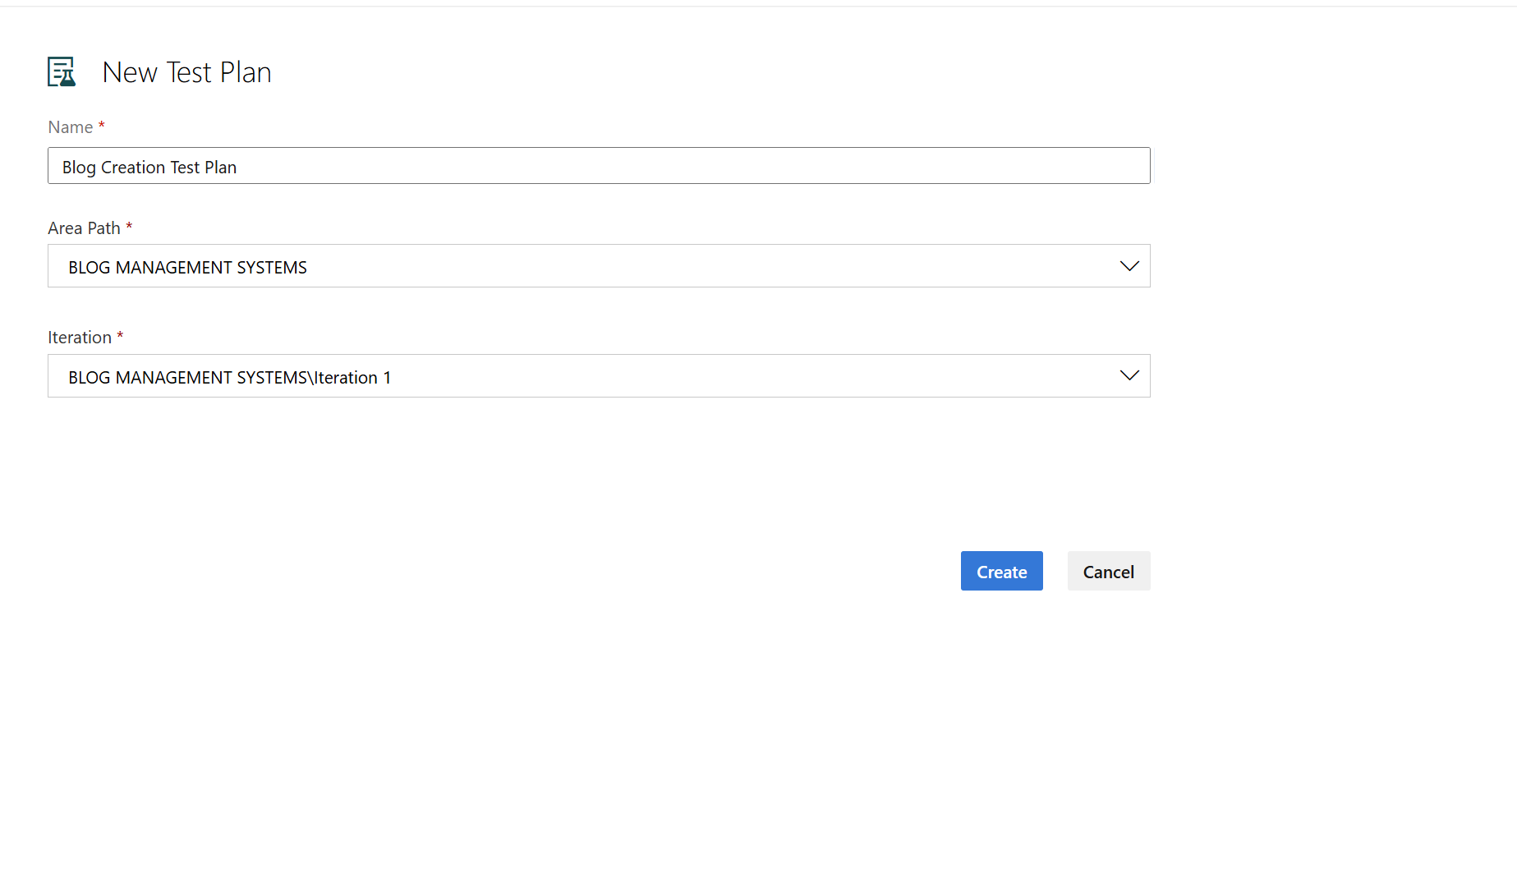

**2.Test suite**

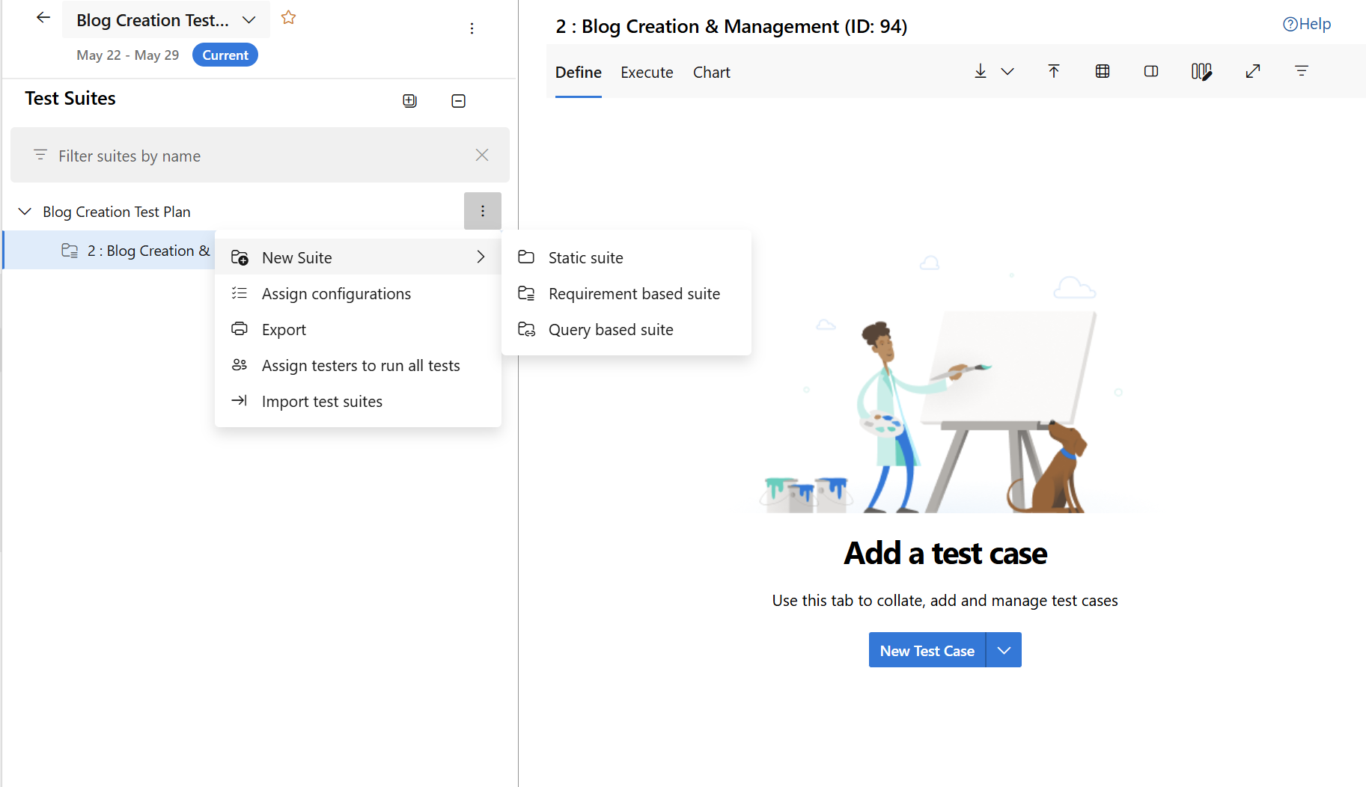

**3.Test case**

Give two test cases for at least five user stories showcasing the happy path and error scenarios in azure DevOps platform.

Blog Management System – Test Plans

**USER STORIES**

* As a Blogger, I want to log in with my login credentials so that I can access my dashboard and content.
* As a Viewer, I want to visit the website so that I can browse blogs without signing in.
* As a Blogger, I want to create a blog so that I can share my content.
* As an Admin, I should be able to publish, edit, and delete posts and pages so that I can manage blog contents.
* As a Blogger, I want to sign up using my unique name and password so that I can access my blogging account.

**TEST SUITES**

**TEST SUITE: TS01 – USER LOGIN**   
 Test Case: TC01 – Login with Valid Credentials  
 User Story: As a Blogger, I want to log in with my login credentials so that I can access my dashboard and content.  
 Test Type: Happy Path  
 Steps and Expected Results:  
 ● Action: Navigate to the login page  
 Expected Result: Login page is displayed with email and password fields  
 ● Action: Enter valid email and password  
 Expected Result: Input is accepted with no errors  
 ● Action: Click the "Login" button  
 Expected Result: Blogger is redirected to the dashboard  
 Notes: This test simulates a successful login with valid credentials.

**Test Case: TC02** – Login with Invalid Password  
 User Story: As a Blogger, I want to log in with my login credentials so that I can access my dashboard and content.  
 Test Type: Error Path  
 Steps and Expected Results:  
 ● Action: Navigate to the login page  
 Expected Result: Login page is displayed  
 ● Action: Enter valid email and incorrect password  
 Expected Result: Password is rejected  
 ● Action: Click the "Login" button  
 Expected Result: Error message “Incorrect password” is shown  
 Notes: Ensures failed login attempts are handled properly with informative error messages.

**TEST SUITE: TS02** – VIEW BLOGS WITHOUT LOGIN   
 Test Case: TC01 – Access Blogs as a Viewer  
 User Story: As a Viewer, I want to visit the website so that I can browse blogs without signing in.  
 Test Type: Happy Path  
 Steps and Expected Results:  
 ● Action: Open the website homepage  
 Expected Result: Homepage with blogs is displayed  
 ● Action: Scroll or navigate through blog posts  
 Expected Result: Viewer can read blogs without authentication  
 Notes: Validates open access to content for all visitors.

**TEST SUITE: TS03** – BLOG CREATION  
 Test Case: TC01 – Create a New Blog Successfully  
 User Story: As a Blogger, I want to create a blog so that I can share my content.  
 Test Type: Happy Path  
 Steps and Expected Results:  
 ● Action: Log in to the dashboard  
 Expected Result: Dashboard with "Write a blog" option is displayed  
 ● Action: Click on "Write a Blog", enter title and content  
 Expected Result: Fields accept inputs with no validation errors  
 ● Action: Click "Publish"  
 Expected Result: Blog is successfully created and visible in public feed  
 Notes: Tests standard functionality for creating a new blog.

**TEST SUITE: TS04** – USER REGISTRATION   
 Test Case: TC01 – Sign Up with Valid Details  
 User Story: As a Blogger, I want to sign up using my unique email and password so that I can access my blogging account.  
 Test Type: Happy Path  
 Steps and Expected Results:  
 ● Action: Navigate to the sign-up page  
 Expected Result: Registration form is displayed  
 ● Action: Enter a unique email and password  
 Expected Result: Inputs are accepted and no validation errors occur  
 ● Action: Click "Sign Up"  
 Expected Result: Account is created and Blogger is redirected to dashboard  
 Notes: Validates successful registration for new users.

**Test Case: TC02** – Sign Up with Existing email and password  
 User Story: As a Blogger, I want to sign up using my unique email and password so that I can access my blogging account.  
 Test Type: Error Path  
 Steps and Expected Results:  
 ● Action: Navigate to the sign-up page  
 Expected Result: Registration form is displayed  
 ● Action: Enter a email that already exists  
 Expected Result: Form accepts input  
 ● Action: Click "Sign Up"  
 Expected Result: Error message “Email invalid” is shown  
 Notes: Ensures duplicates are not allowed.

**TEST SUITE: TS05** – CONTENT MANAGEMENT BY ADMIN   
 Test Case: TC01 – Admin Manages Blog Posts  
 User Story: As an Admin, I should be able to publish, edit, and delete posts and pages so that I can manage blog contents.  
 Test Type: Happy Path  
 Steps and Expected Results:  
 ● Action: Log in to the admin panel  
 Expected Result: Admin dashboard is displayed  
 ● Action: Choose an existing blog post and select “Delete”  
 Expected Result: The Blog gets deleted  
  
 Notes: Tests core content control actions available to Admin.

**Test Cases**

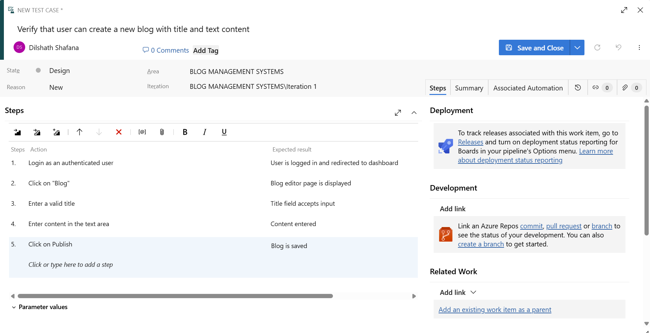

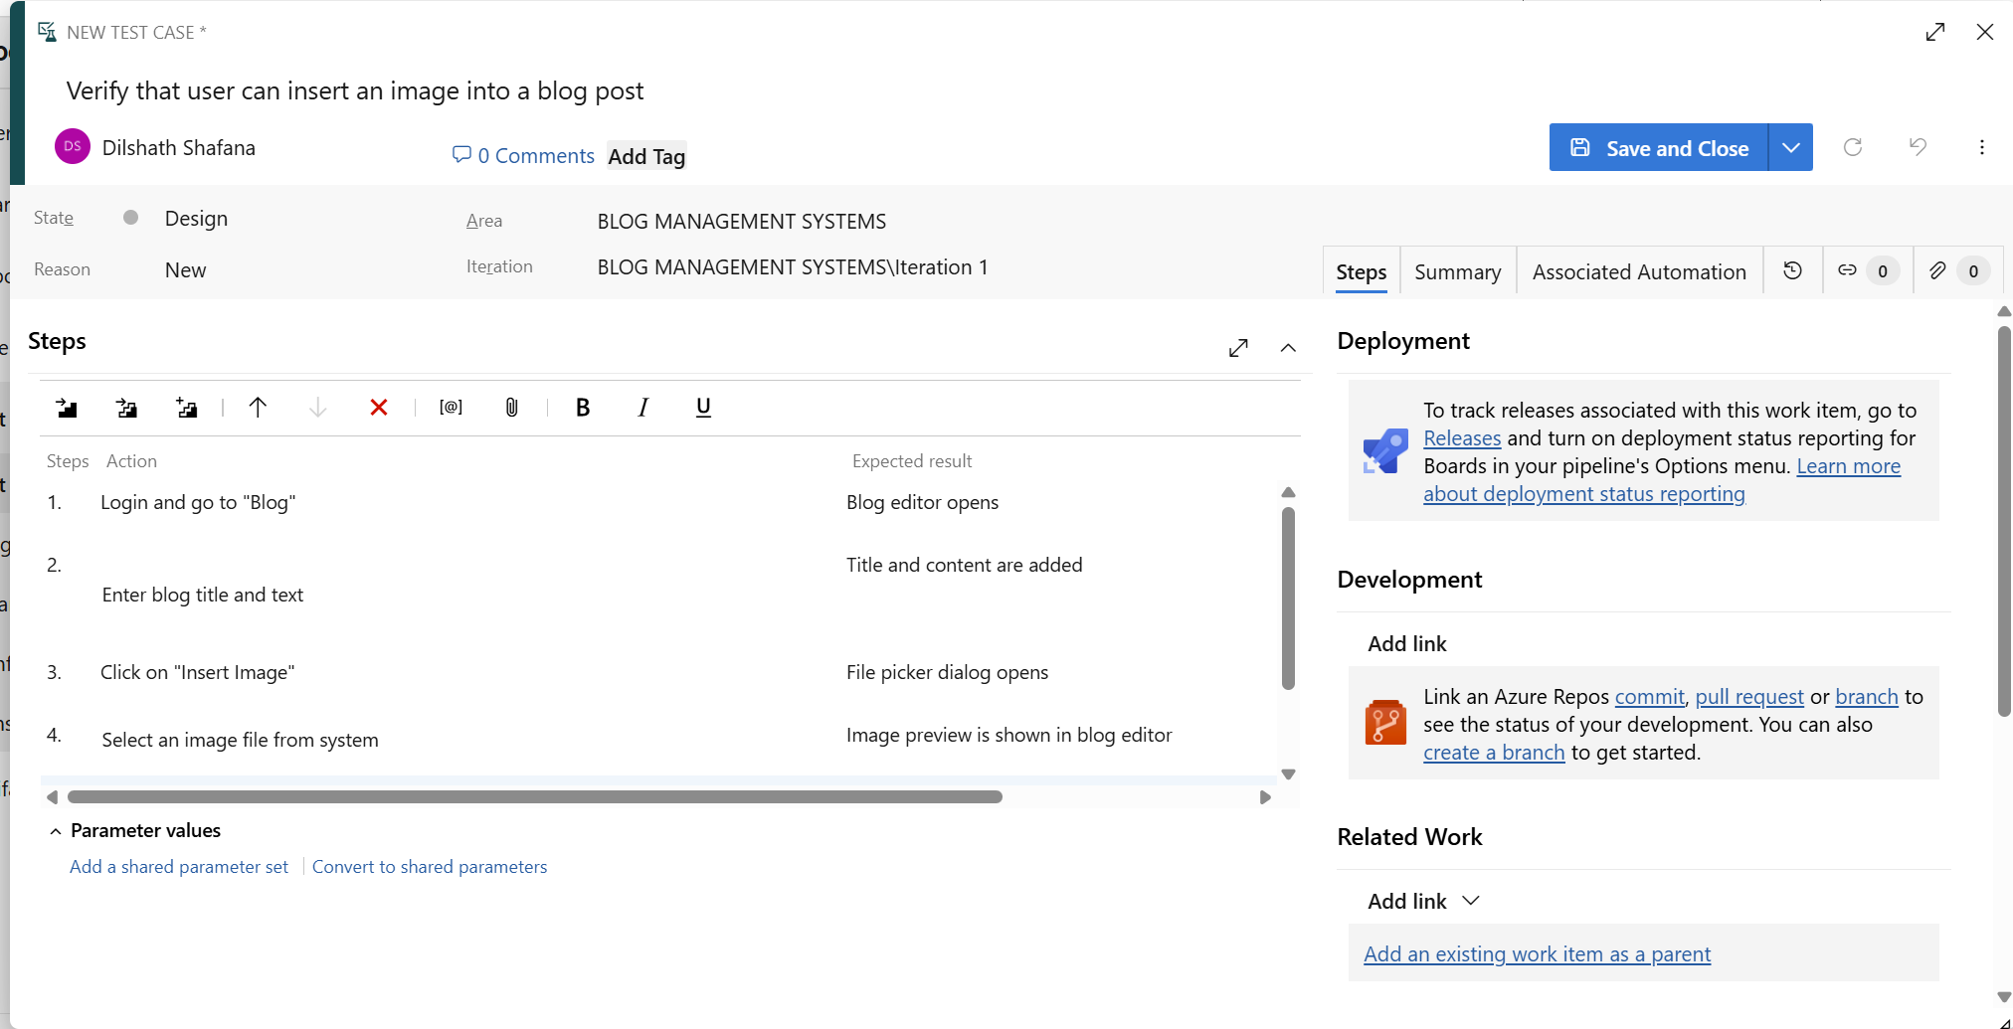

**4.Installation of test**

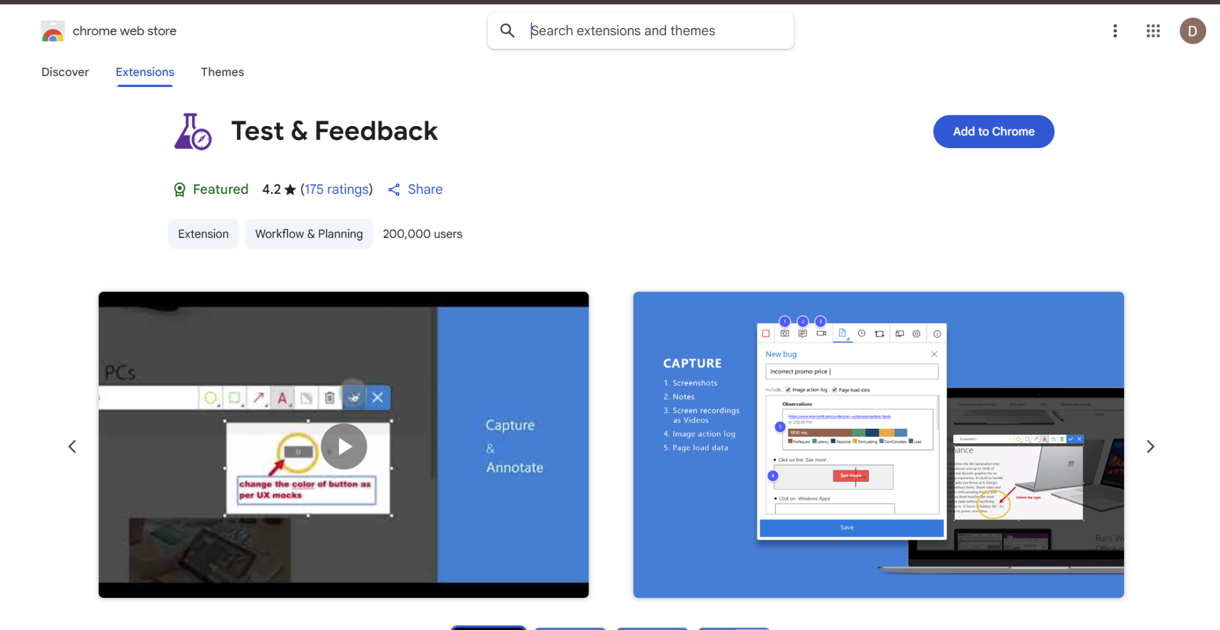

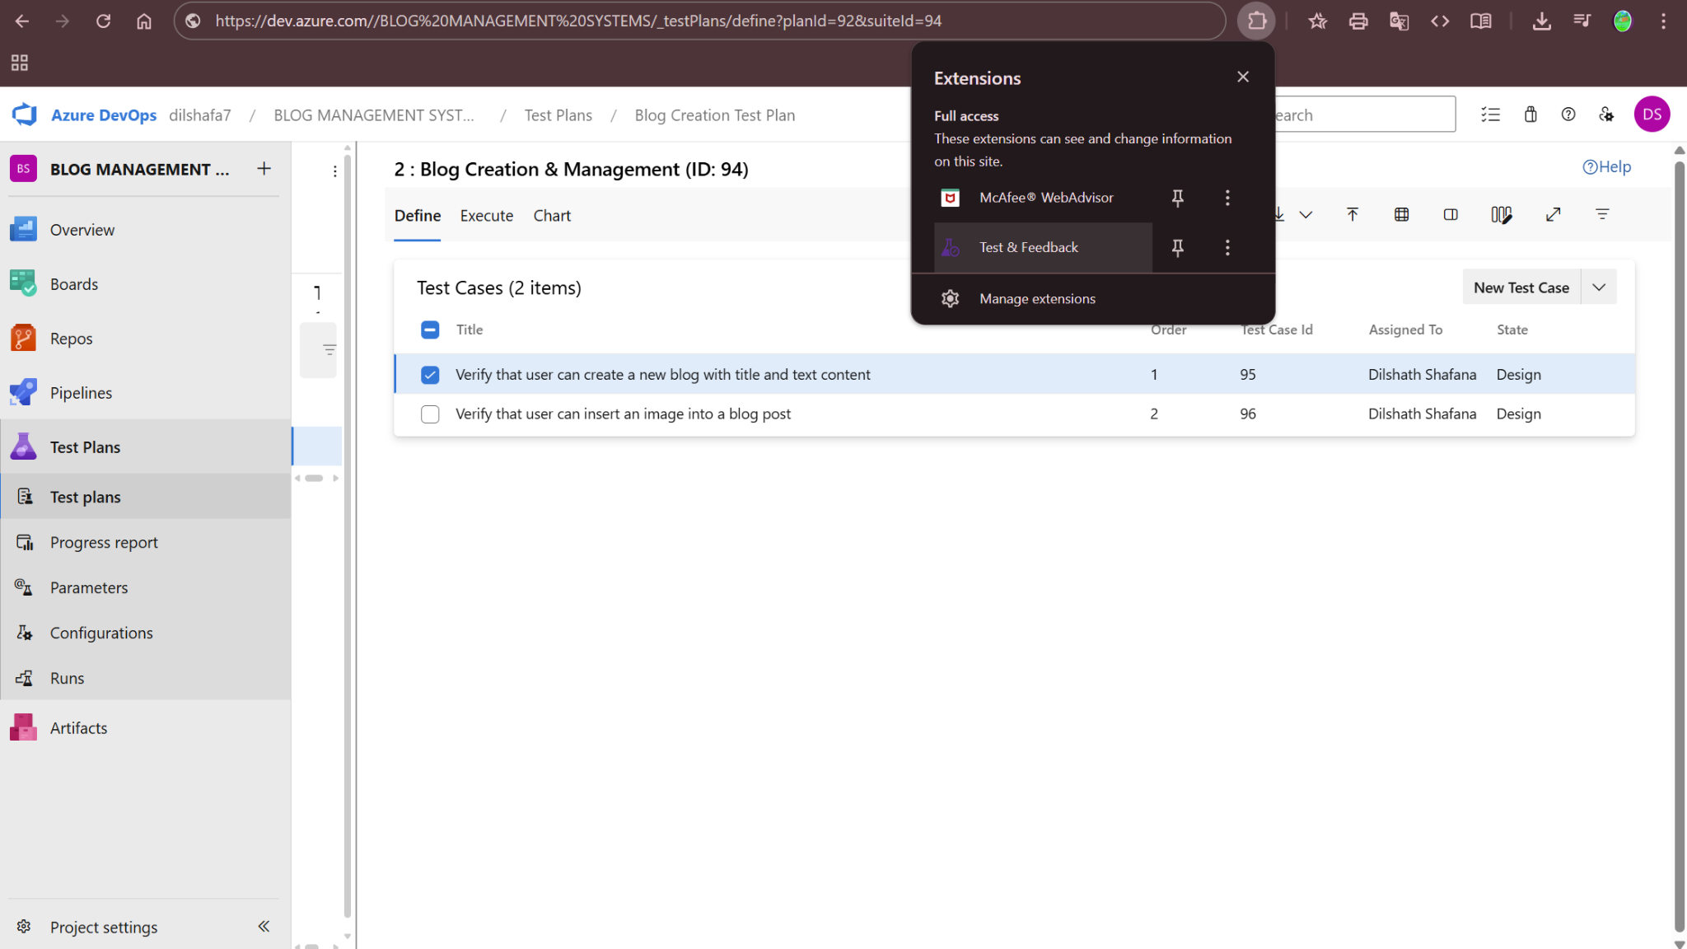

Test and feedback

Showing it as an extension

**5.Running the test cases**

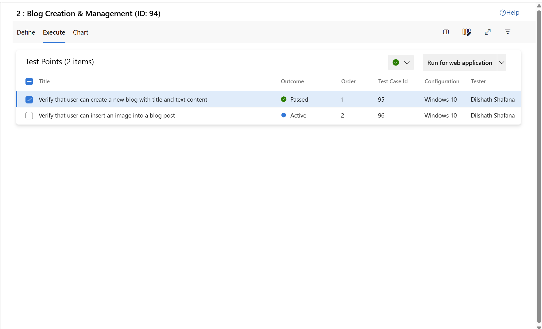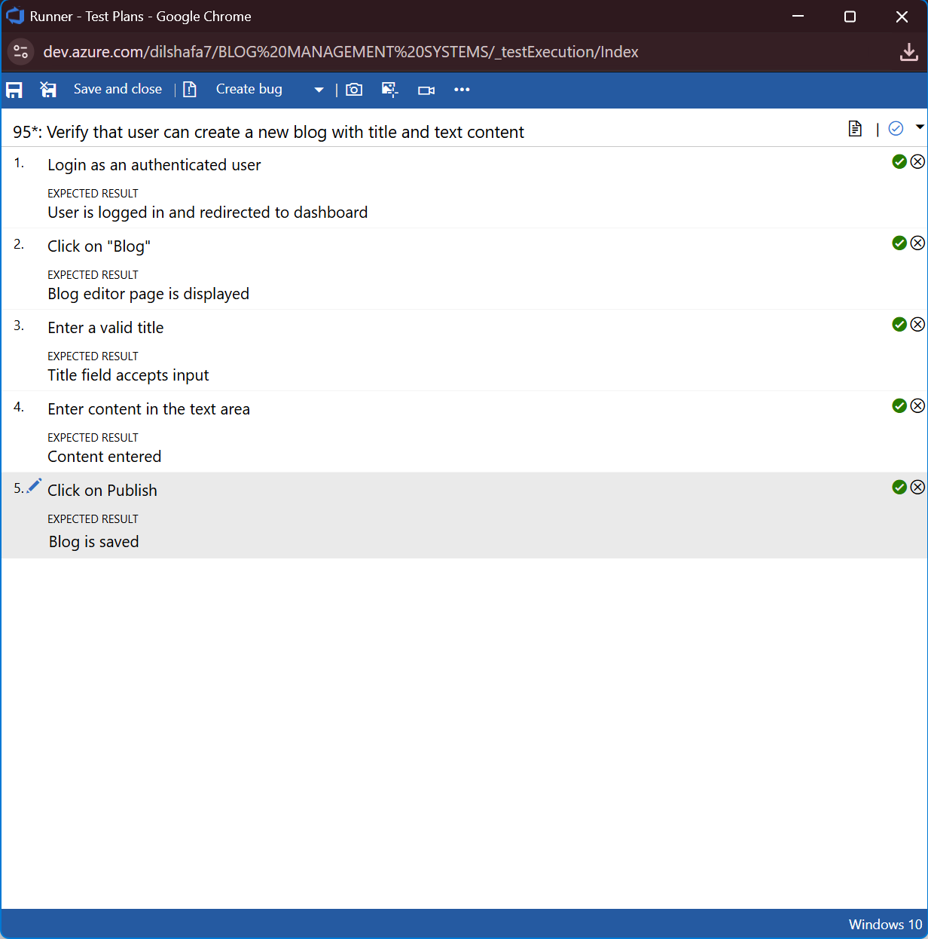

**6.Recording the test case**

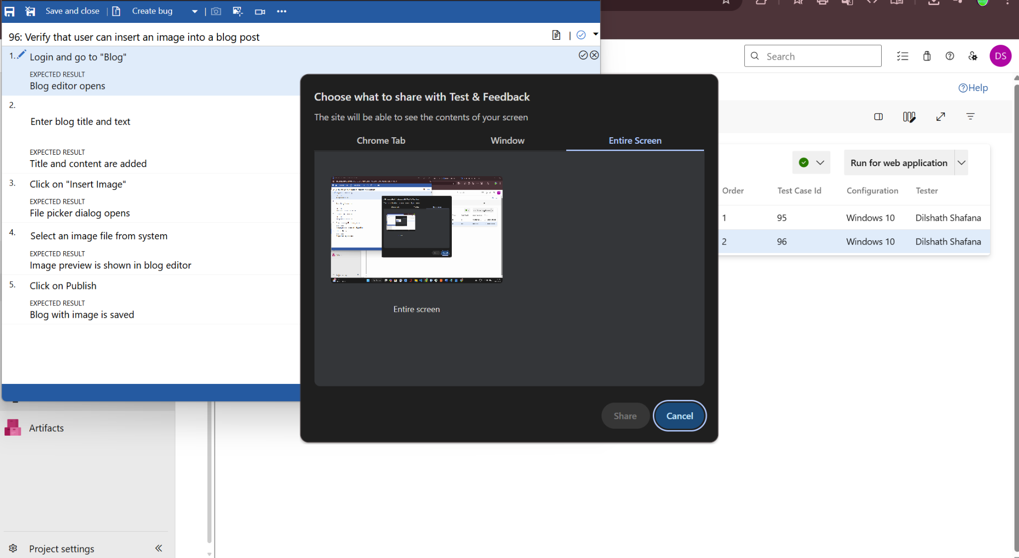

**7.Creating the bug**

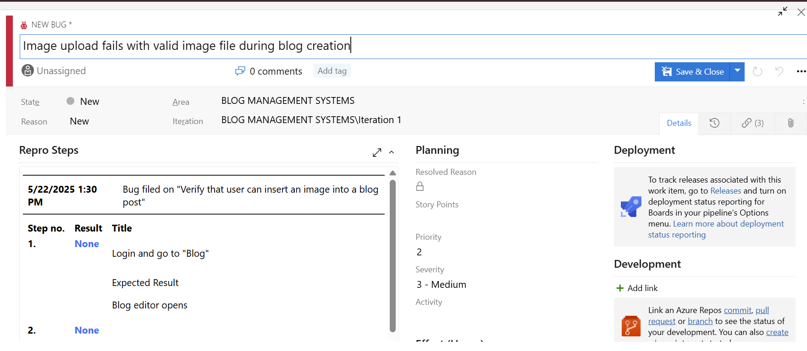

**8.Test case results** 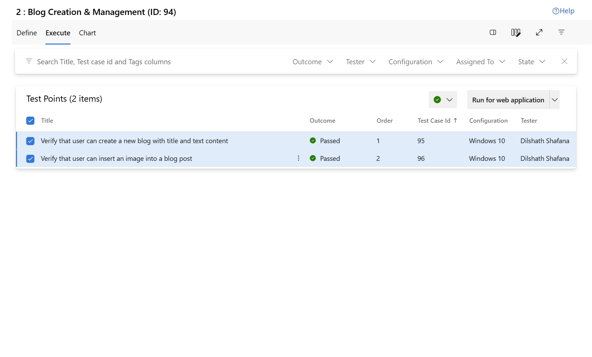

**9.Test report summary**

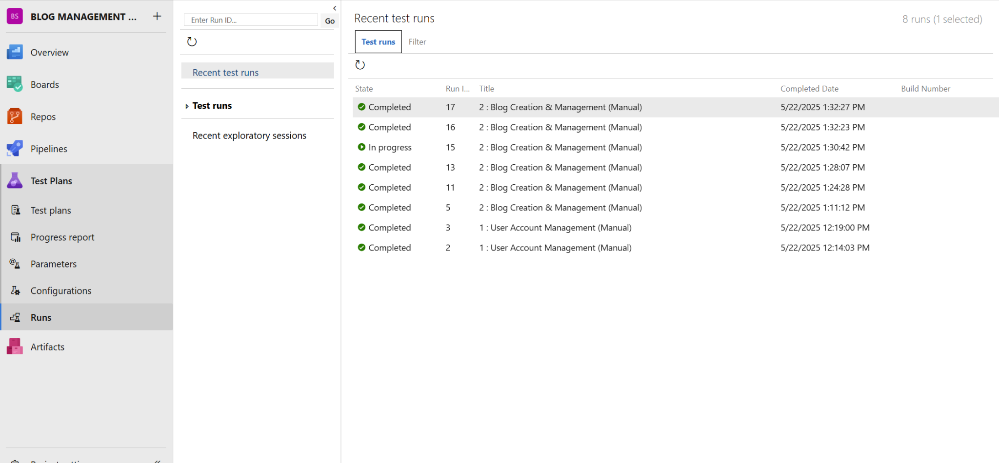

**10.Progress report**

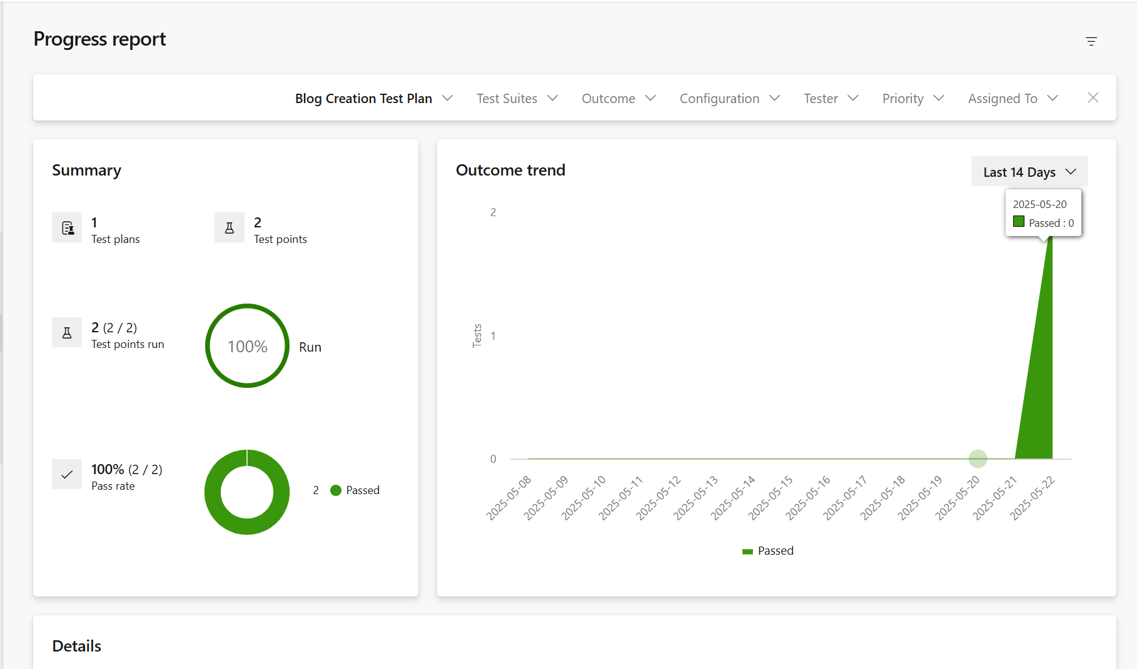

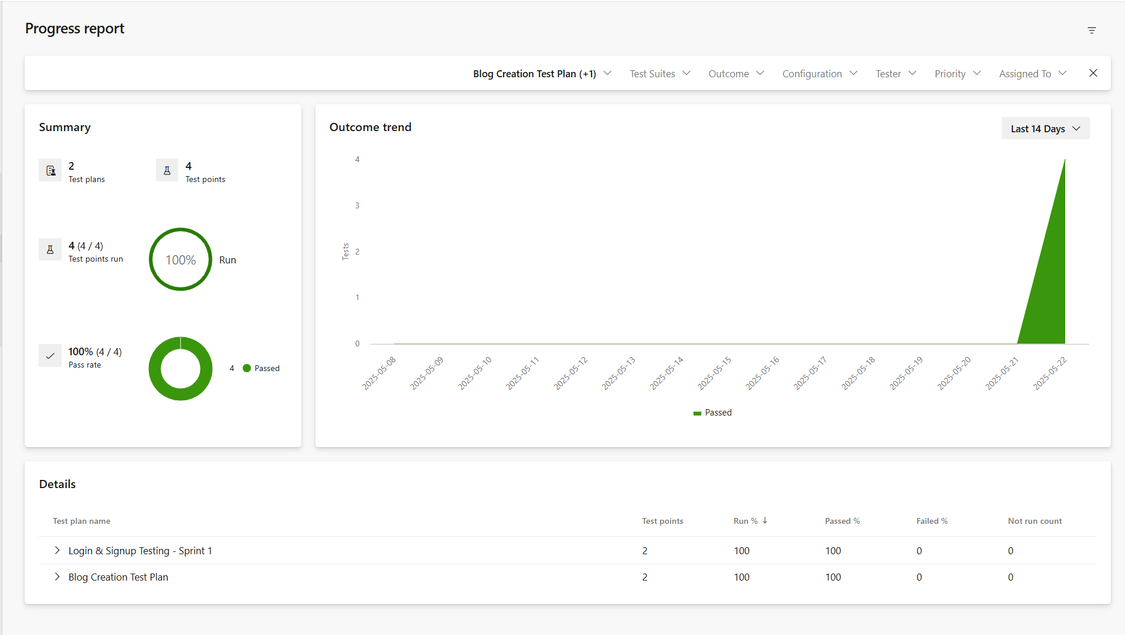

**11.Changing the test template**

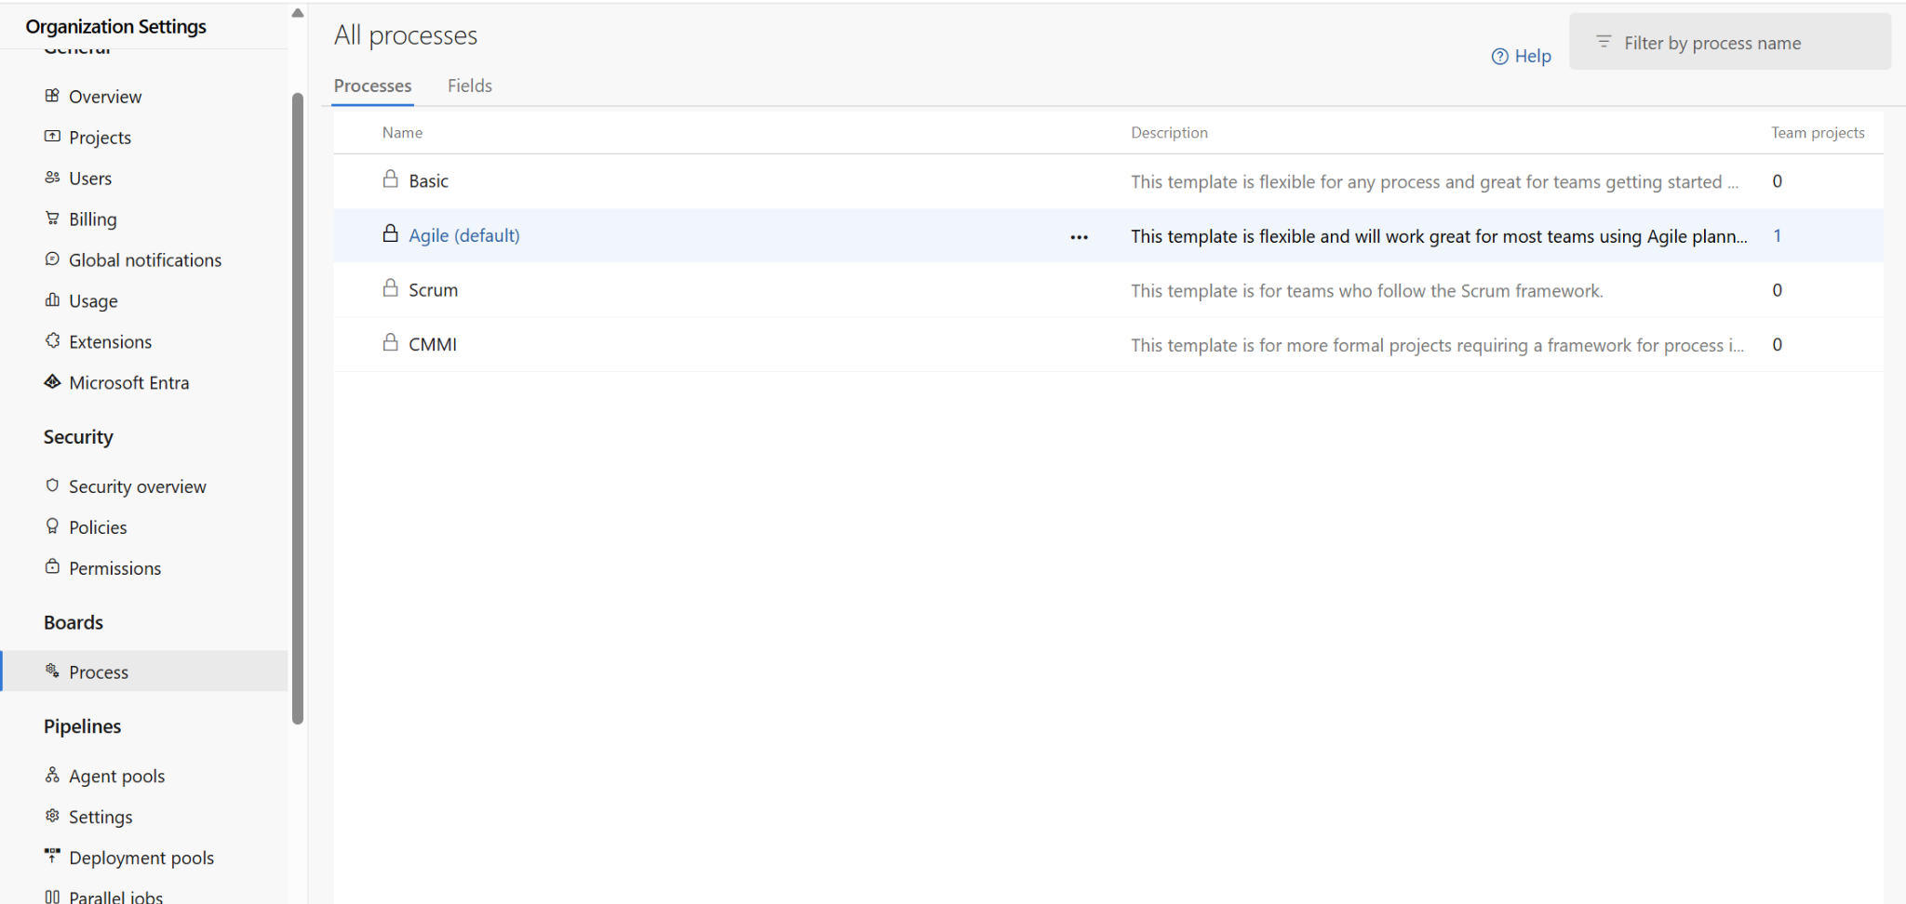

**12.View the new test case template**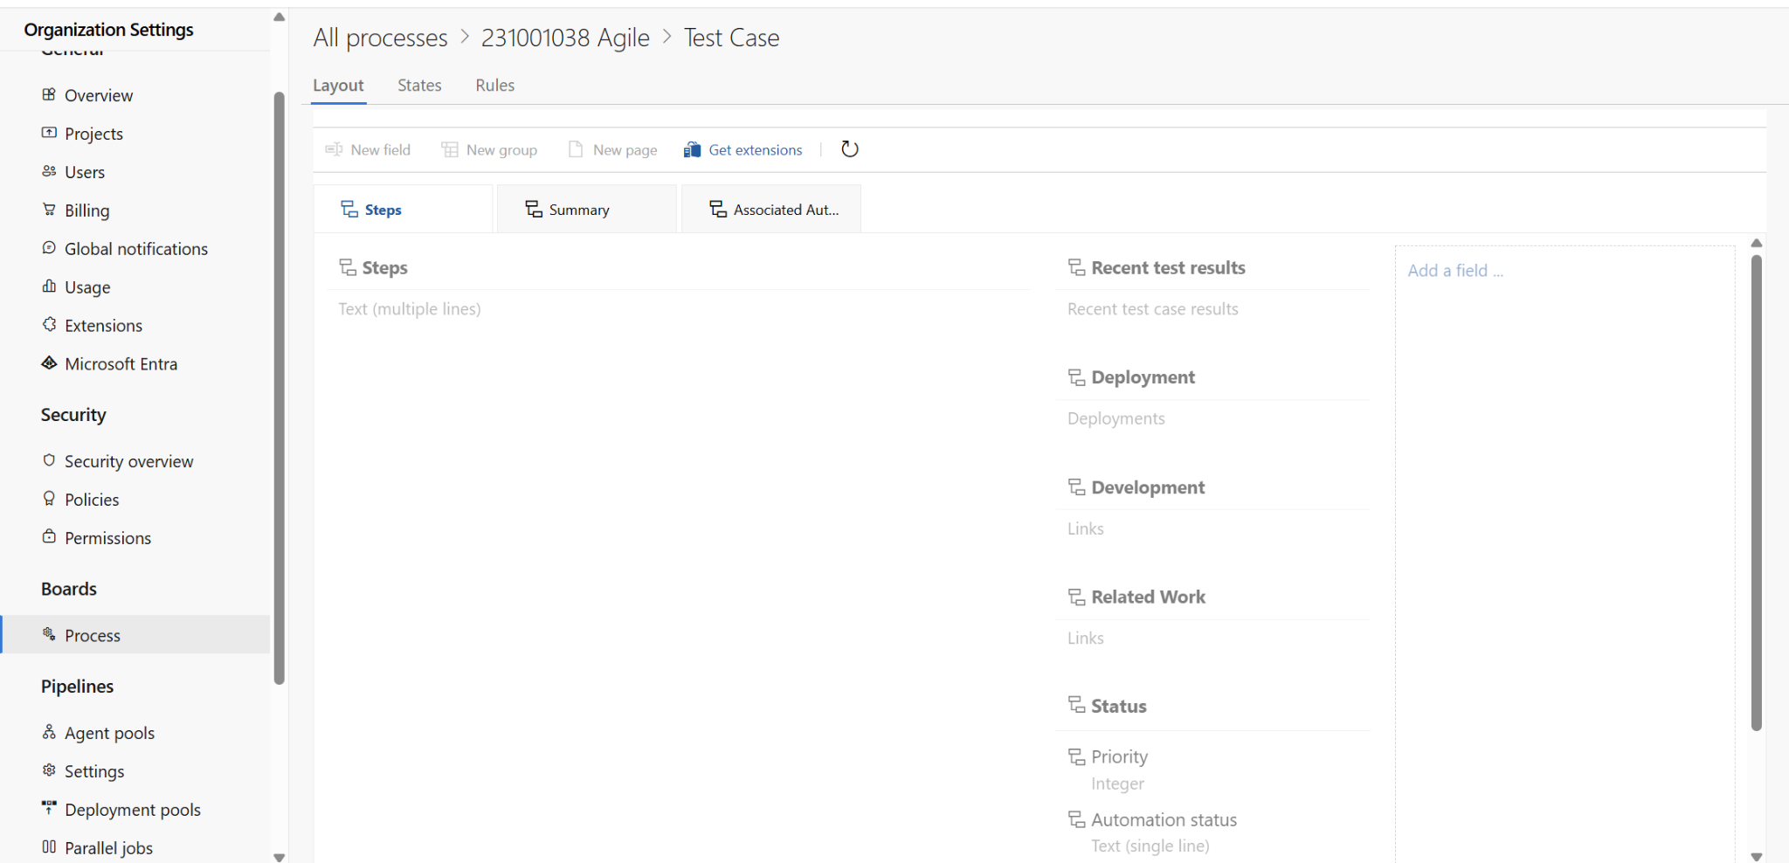

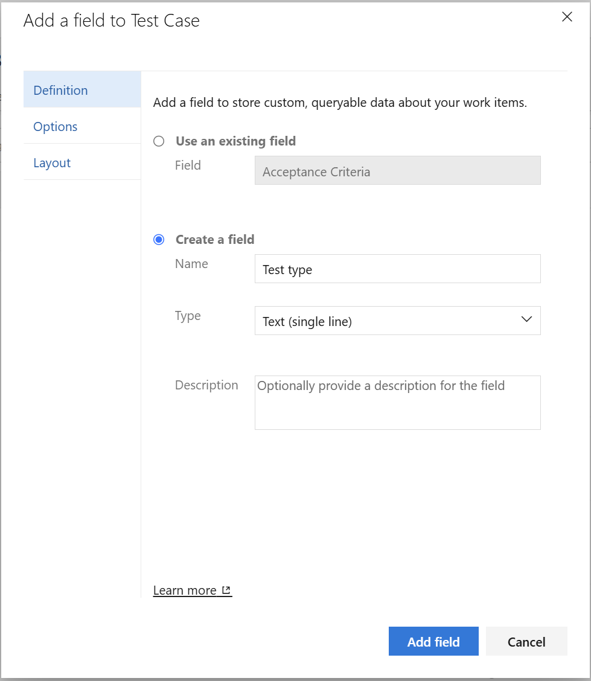

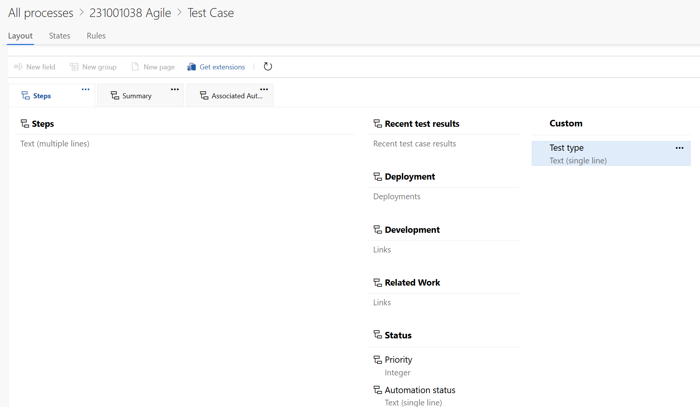

**Result:**

The test plans and test cases for the user stories is created in Azure DevOps with Happy Path and Error Path.

| **EX NO: 09**  **Date:25/04/2025** | **LOAD TESTING AND PERFORMANCE TESTING** |
| --- | --- |

**Aim:**

To create an Azure Load Testing resource and run a load test to evaluate the performance of a target endpoint.

**Load Testing**

**Steps to Create an Azure Load Testing Resource:**

Before you run your first test, you need to create the Azure Load Testing resource:

1. Sign in to Azure Portal

Go to https://portal.azure.com and log in.

2. Create the Resource

o Go to *Create a resource* → Search for “Azure Load Testing”.

o Select Azure Load Testing and click Create.

3. Fill in the Configuration Details

o Subscriptio*n:* Choose your Azure subscription.

o *Resource Group:* Create new or select an existing one.

o *Name:* Provide a unique name (no special characters).

o *Location:* Choose the region for hosting the resource.

4. (Optional) Configure tags for categorization and billing.

5. Click Review + Create, then Create.

6. Once deployment is complete, click Go to resource.

**Steps to Create and Run a Load Test:**

Once your resource is ready:

1. Go to your Azure Load Testing resource and click Add HTTP requests > Create. 2. Basics Tab

o *Test Name:* Provide a unique name.

o *Description:* (Optional) Add test purpose.

o *Run After Creation:* Keep checked.

3. Load Settings

o *Test URL:* Enter the target endpoint (e.g., https://yourapi.com/products).

4. Click Review + Create → Create to start the test.

**Load Testing**

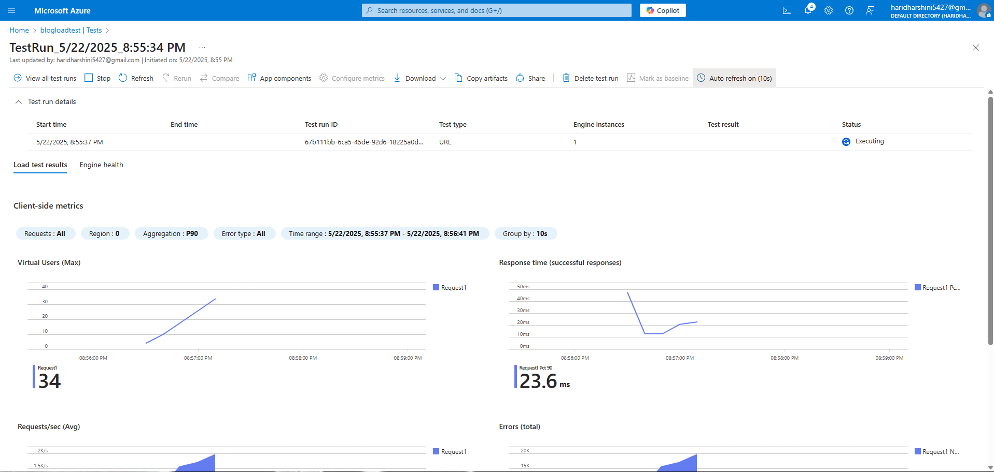

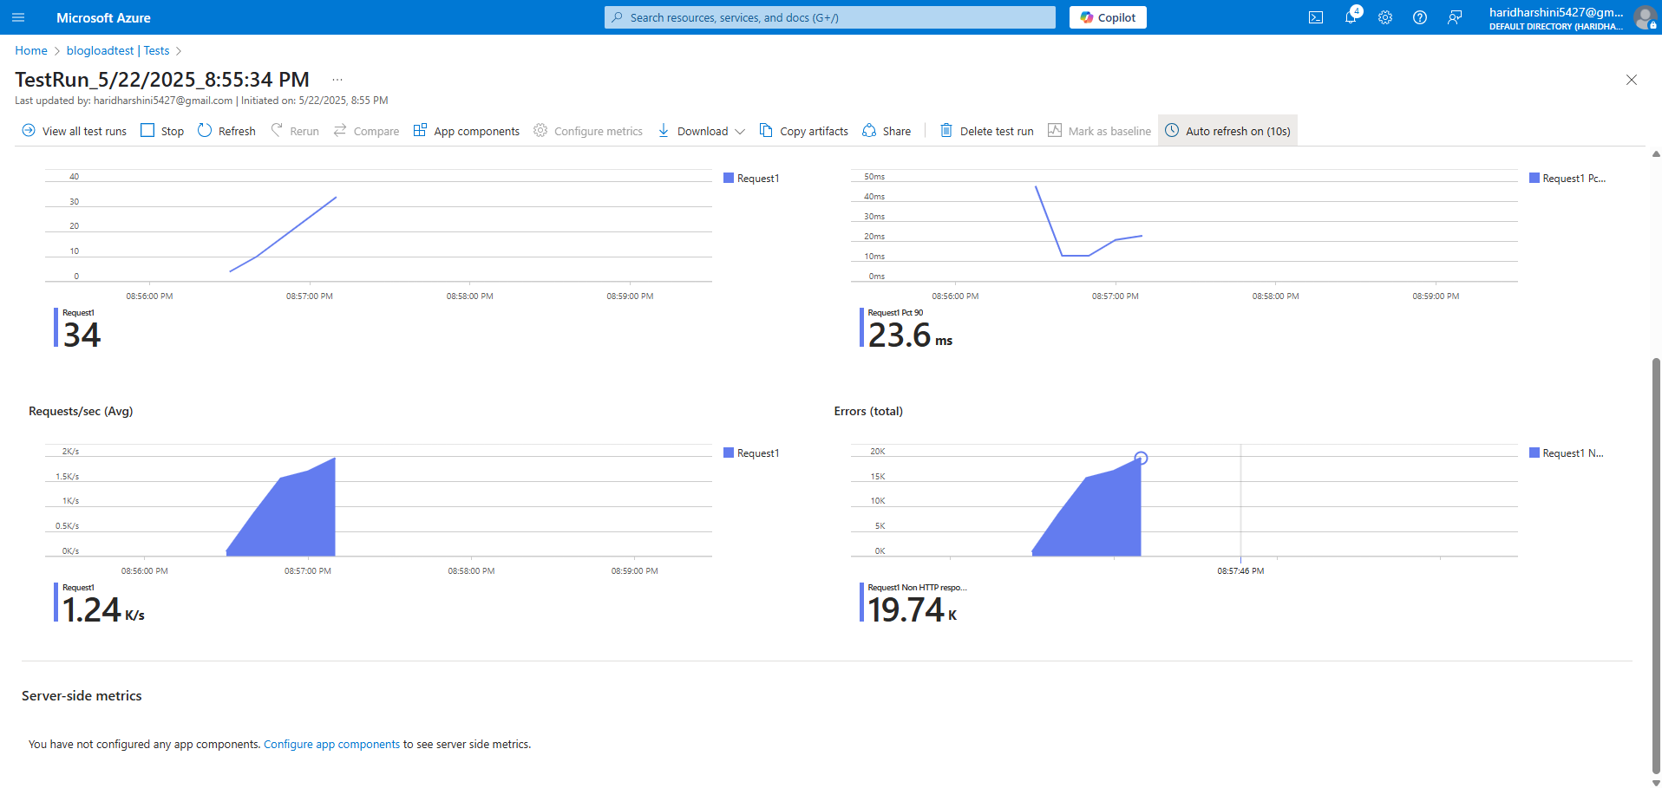



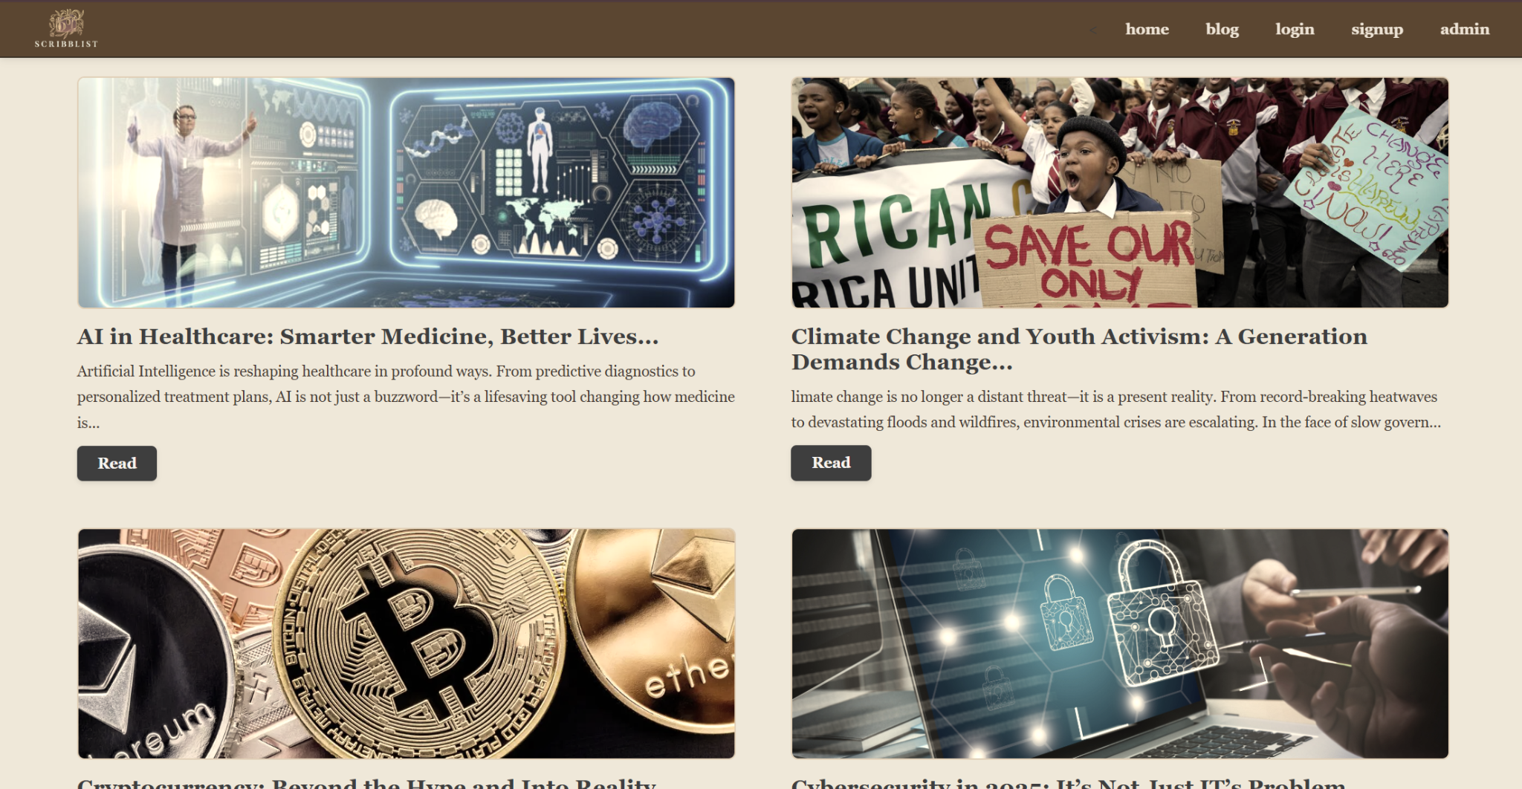

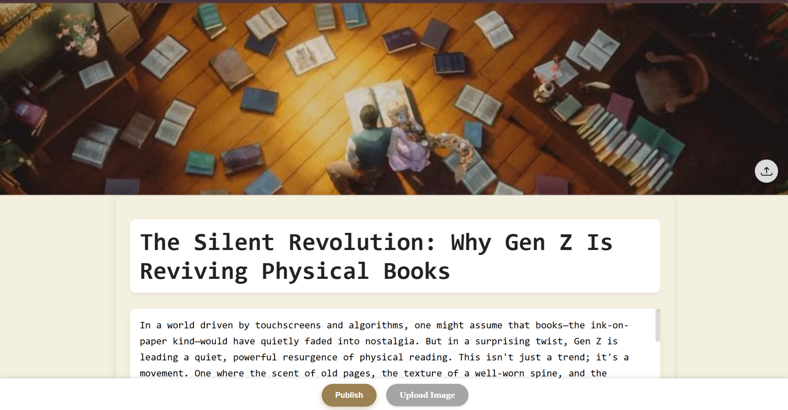

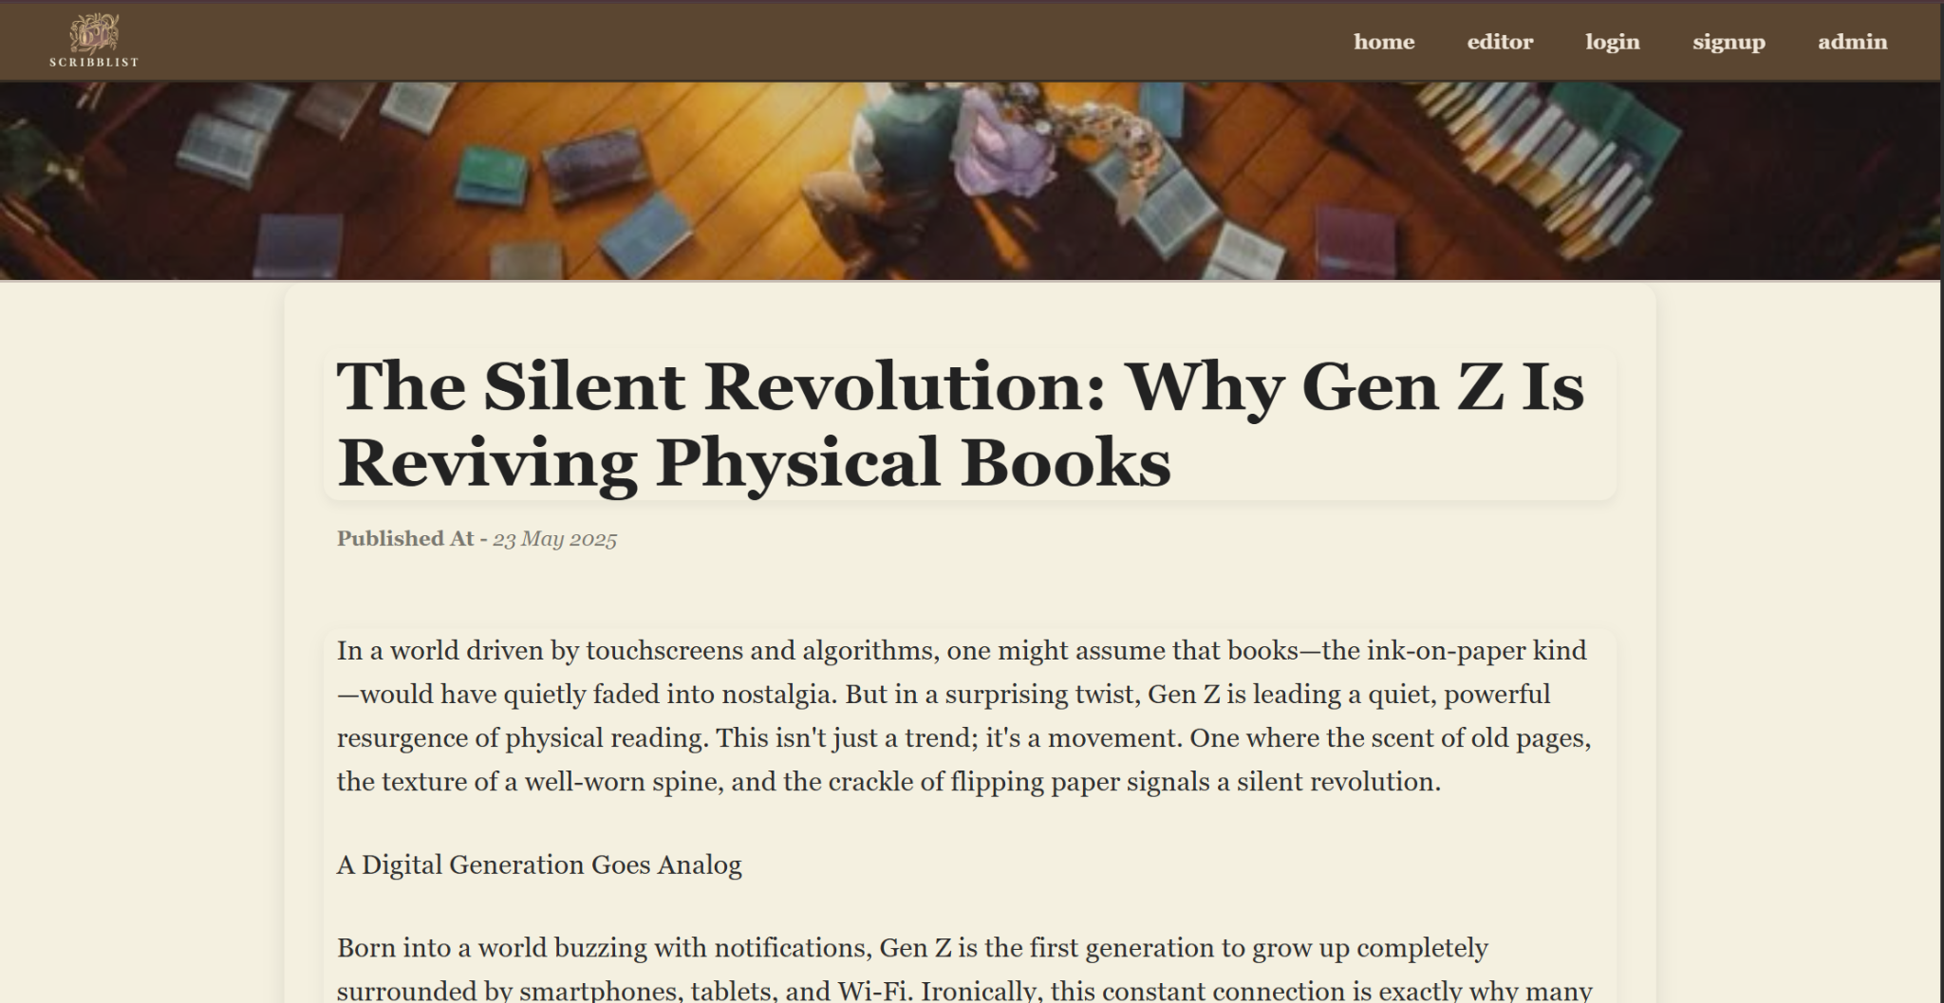

**Result:**

Successfully created the Azure Load Testing resource and executed a load test to assess the performance of the specified endpoint

| **EX NO: 10**  **Date:02/05/2025** | **GITHUB: PROJECT STRUCTURE & NAMING CONVENTIONS** |
| --- | --- |

**Aim:**

To provide a clear and organized view of the project's folder structure and file naming conventions, helping contributors and users easily understand, navigate, and extend the Blog management system project.

**GitHub Project Structure:**

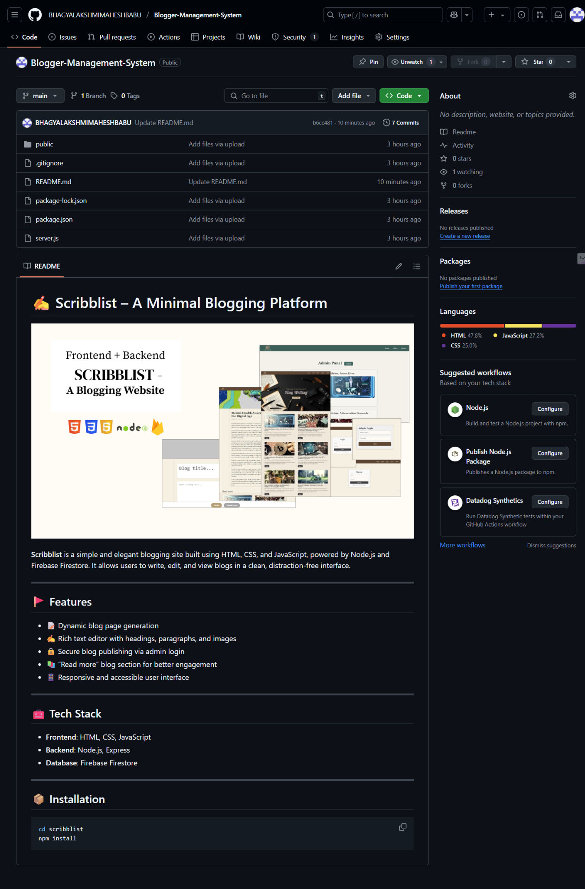

**Result:**

The GitHub repository clearly displays the organized project structure and consistent naming conventions, making it easy for users and contributors to understand and navigate the codebase.